Stage 1
Before submitting the documents for the defense of the master thesis make sure you have done the following:
- Checked the title of your master thesis (See your Student’s or your Research Supervisor’s account) and put the date (dates, if renewed once or twice), and the Order number of the Приказ into the master thesis assignment.
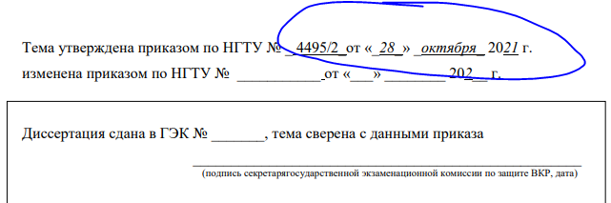
- Uploaded your manuscript Your name_ Master thesis.pdf in your Student’s Account, and it was approved by your Research supervisor in the account.

Stage 2
By 05.06.2024 prepare the following documents:
- Print out an antiplagiarism report with the percentage from your Student’s Account, and with your name and the title of your master thesis included.
- From your Student’s Account print out the Licensed agreement with NSTU /Лицензионный договор (2 items) doubled-sided, and write down your passport details but no dates.
- Print your master thesis (Better one item for a start. In case something is wrong and needs to be corrected, you will make the new one.) The second item is also needed for the Examination Board but after the defence it will be your sweet memory.
The front cover is transparent.
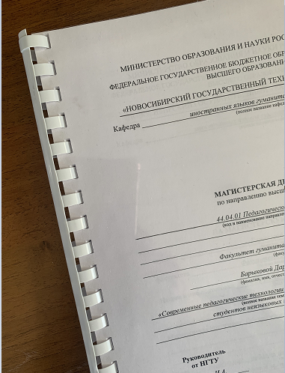
Leave a title page and an assignment (printed double-sided) non-numbered.
A visible page number first appears on a TABLE OF CONTENTS, and it is 2.
- Read a review of your research supervisor and an external expert uploaded to your Student’s Account or given to you in e-or printed version by your Research supervisor.

Stage 3
On 05.06.2024 on the time agreed but in the period 9:00 - 14:00 you come to 6-305 for submitting all the documents to your Research supervisor:
- ONE printed version of your master thesis. Together with your research supervisor you are putting all dates and signatures. (If something is incorrect you bring a corrected version the same day.)
- ONE antiplagiarism report. Your research supervisor is putting the date and signature on the report.
- TWO Licensed agreements with NSTU filled in.

You will be given your master thesis review made by your research supervisor for you to put a signature that you are familiar with it.
You will be given your master thesis review made by an external expert for you to put a signature that you are familiar with it.
Together with your research supervisor you are submitting all the documents mentioned above to Karina Vilyaevna, a secretary of the Department, and filling in the Log for accepted documents to start the defense procedure.
Remember to bring your passport and show it to Karina Vilyaevna.

