PRACTICE. Real English - How to Talk to the Police
Exercise 1
 |  |  |  |  |  | 5 |  |  |  |  | 4
 |  |  |  |  |  |  |  |  | 3
 |  |  |  |  |  |  |  |  |  |  |  |  |  |  |  |  |  | 2
 |  |  |  |  | 1
7 |  |  |  |  |  |  |  |  |  |  |  |  | 6
По вертикали:
2) not a prison, but a light ban (2 words)
3) rules that apply only to you (2 words)
4) you can pay and they will let you go. You get paper and pay later (1 word)
5) you have the right to ask questions to the police, for example ask for a police badge (1 word)

По горизонтали:

1) accepted by your city government (2 words)
6) the police must tell you what you are accused of (1 word)
7) punishment when you did something bad (1 word)

Exercise 2

Choose the right definition to the picture.

1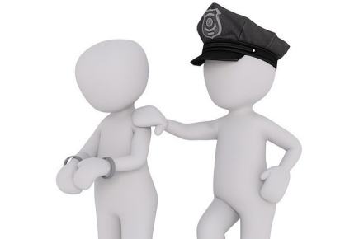
a) Bail
b) Break the low
c) Let you off with a warning
d) Light punishement
2 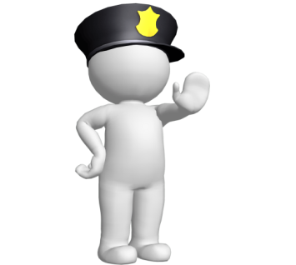
a) To jail
b) Under arrest
c) Be charge with
d) Stop
3 
a) To bail
b) Fine
c) Let you off with a warning
d) Flunk the Attitude test

4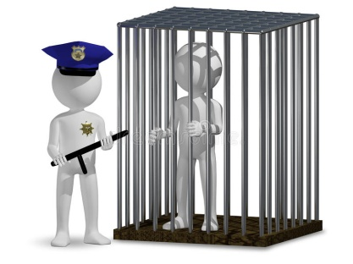
a) To bail
b) To jail
c) to arrest
d) Flunk the Attitude test

5 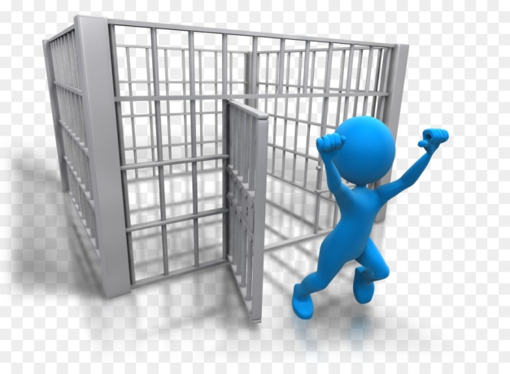
a) To bail
b) To jail
c) Be charge with
d) Let you off with a warning

Exercise 3
https://learningapps.org/watch?v=pavrrf9ra22



Exercise 4

 |  |  |  |  |  |  |  | 5
 |  |  |  |  | 6
 |  |  |  |  |  |  |  |  |  | 2
 |  |  |  |  |  | 4
 |  |  |  |  |  |  | 1
 |  | 8 |  |  |  | 3
7

- Where are the criminals sitting?
- A person has committed a crime and now will receive…..
- The driver exceeded the speed limit and received a…….
- When the criminal ran away, the police shouted…….
- А moral or legal claim to have or get something or to behave in a particular way
- It is made for a person to be at home before the trial
- The group of people who are responsible for controlling a country or a state
- the place where legal trials take place and where crimes

Exercise 5

Task: complete the sentences with words (do not forget about prepositions, articles, etc.; one has extra meaning).
bail; to court; court; punishment; the attitude; jail; arrest; Government; fine; charge; rights; with a warning

- They took their landlord … for breaking the contract.
- The … has been considering further tax cuts.
- This important case confronts the issue of what constitutes cruel and unusual … .
- Can anyone put up … for you?
- He has been released from …
- During the … hearing, the prosecutor said she would seek maximum prison sentences.
- Other than a few damp spots, the place looked … .
- We need to protect the … of those that would oppressed by the majority.
- He will be sent back to England to face a ... of armed robbery.
- He was under … as he violated the law.
- He ran a red light, the policeman let him off … .
- He was rude to the police on duty, he flunked … test and was arrested.

Exercise 6

Fill the gaps with the words below:
ID, rights, charged with, fine, arrest, jail, bail, break the law, let someone off with a warning

1. Listen, officer, I know my _____ really good. Please, tell me your name and show me your badge first.
2. Hey, you! Stop right there! You’re under ____!
3. Sir, it’s forbidden to park here. I must ___ you.
4. Remember this: if you ever ________ you will be punished by the police.
5. For such a terrible crime even the worst ____ in the world won’t be enough for you, scumbag!
6. Sorry, officer, what am I _______? I still don’t understand what I’ve done…
7. In order to get out of here I need a lot of money to pay the ____.
8. Please, show me your ____, sir. Do you have a passport or a citizen card with you?
9. This time I’ll ________________, but next time I’ll fine you.

Exercise 7

Fill in the gaps with the word corresponding to its definition. Pay attention to the verb tenses.
- Why don't they put the bad guy in …. (a place where criminals are kept as a punishment)?
- Human … (freedom to do and say things without fear of punishment) are recognized and guaranteed in the Russian Federation.
- Moreover he hoped that the … (someone whose job is to understand the law and deal with legal situations) might be able to give him some assistance in solving what was beginning to look like a rather puzzling problem.
- Well, I suggest we leave the question of … (an arrangement in which money is paid to a court so that someone can be released from prison until their trial) till morning.
- This guy … (derived to not punish somebody for something they have done wrong, or to give them only a light punishment) for the last time. The consequences will be worse in the future.
- He … (If the police charge someone, they accuse them officially of a crime) with assault.
- She told … (the place where a judge decides whether someone is guilty of a crime) what happened on the night of the murder.
- How many times has he already … (do something illegal)?
- I never go anywhere without my … (passport).
- The court gave her two weeks to pay … (an amount of money that you must pay for breaking a law or rule).

Exercise 8

Put a suitable word or expression in the missing place.
badge number, was charged, money, be under arrest, identity cards, jail, driving license, fine, let him go with a warning, court, bail

1. It's not fair that he ______ of this. He's innocent, isn't he?
2. There are no ______ in Canada, but there is a passport.
3. He has committed murder and now he will go to _____.
4. For speeding, there is usually a _____.
5. A policeman's _____ is almost the same as having a state number plate on his car.
6. Because the cyclist was polite, the police officer _____.
7. The Supreme _____ is one of the highest _____ in the United Kingdom.
8. If an arrested person posts _____ this ensures that they attend the trial.
9. If you successfully pass your driving test in a driving school, you are issued with a _____.
10. If they had evidence, you would already _____.

