STOP AND CHECK
1. Consider the facts and specify upon them | 2. Choose the correct  alternative
a. Carbohydrates, lipids, and proteins constitute the bulk of the diet.  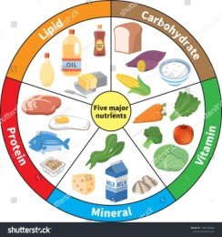  b. You are what you eat.  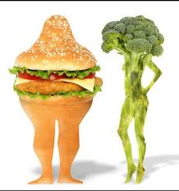  c. Vitamins are required for survival.  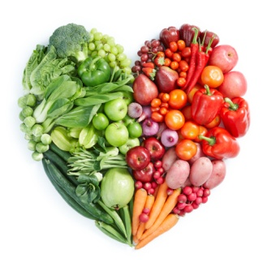 | What makes some processed foods less healthy?  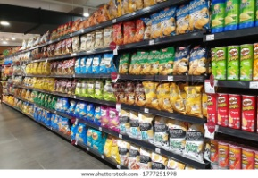  Ingredients such as salt, sugar and fat are sometimes (add / added) (to / for) processed foods to make (their / its) flavour more (appealing / appeal) and to extend their shelf life, or in some cases to (contribute / contribution) to (the / - / a) food's structure, such as salt (in / at) bread or sugar (in / of) cakes.  (Buying / To buy) processed foods can lead to people (eating / to eat) more than the / - / a recommended (amounts / amounting) of sugar, salt and fat as they may not (be aware / aware) (of / at) how much (has been / was) added to (the / a / - ) food they (are buying / buy) and eating.  These foods can also be (higher / highest) in calories due to (the /a / - ) high amounts (of / for) (added / adding) sugar or fat (in / to) them.
3. Complete the sentences choosing the appropriate word  from the box below | 4. Scan the scientific article, identify the group of nutrients discussed
1.Not all processed ________is a bad choice.  2. Some foods need _________to make them safe.  3. Food processing is any method used to turn fresh foods into food __________.  4. Each _______is given a name using a letter of the alphabet.  5. This article covers the major issues of human________, such as energy generation and balance, essential________, and recommended dietary guidelines.  6. The utilization of food materials by all living things is described in nutrition, and specific biochemical processes are described in__________.  7. Most foods provide a mixture of energy-supplying nutrients, along with vitamins, minerals, water, and other __________.  8. Depending on an individual’s level of physical activity, between 50 and 80 percent of the _______expended each day is devoted to basic metabolic processes. | How can I eat processed foods as part of a healthy diet?  You have no control over the amount of salt, sugar and fat in processed food but you do have control over what you to choose to buy.  Reading nutrition labels can help you choose between processed products and keep a check on fat, salt and sugar content.  Most pre-packed foods have the nutrition information on the front, back or side of the packaging.  If the processed food you want to buy has a nutrition label that uses colour-coding, you will often find a mixture of red, amber and green.  When you're choosing between similar products, try to go for more greens and ambers, and fewer reds, if you want to make a healthier choice.  There are guidelines to tell you if a food is high or low in fat, saturated fat, salt or sugar.
  food nutrients processing products metabolism vitamin nutrition substances energy
5. Do the multiple-choice quiz.
1. Human nutrition is …  a. a process by which substances in food are transformed into body tissues and provide energy  b. a process of metabolism  c. a process of transforming essential substances into body tissues | 
2. Human nutrition is …  a. an interdisciplinary science  b. a science of nutrition  c. a science of food and beverages | 
3. Macronutrients are…  a. proteins and fats  b. minerals and vitamins  c. carbohydrates, lipids and proteins | 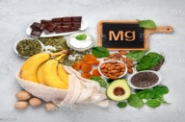
4. Your health is very much determined by…  a. the way you sleep  b. what you eat  c. what you drink | 
5. Micronutrients are…  a. water  b. minerals and vitamins  c. carbohydrates | 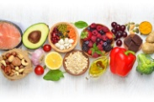
6. A ‘built-in-alarm signal’ is…  a. pain  b. hunger  c. fear | 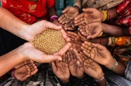
7. A ‘fuel for the body’ is…  a. water  b. food  c. vitamins | 