Unit II. Physical processing
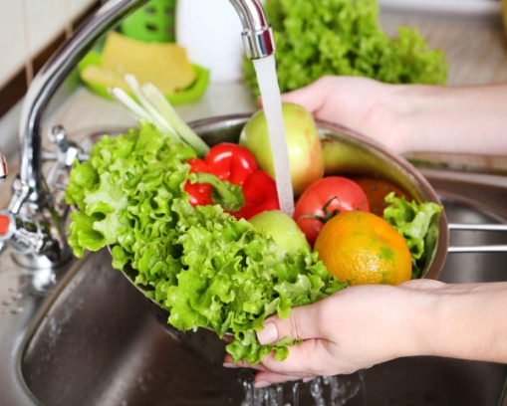  Fig. 20 – Washing | Warm up  1. Answer the questions:  - Why should food be cleaned before further processing?  - Which methods are used to clean food?  - Do cleaning procedures differ for smooth and rough skin produce?  - Can we use any additional means (baking soda, vinegar, detergents) when we clean produce or we should use only plain running water? Why?
2. Practice the pronunciation of the following words:
Contaminate [kənˈtæmɪˌneɪt], surface [ˈsɜːfɪs], suitable [ˈsuːtəbəl], further [ˈfɜːðə], early [ˈɜːlɪ], subsequent [ˈsʌbsɪkwənt], discard [dɪsˈkɑːd], thus [ðʌs], wastage [ˈweɪstɪdʒ], categorise [ˈkætɪɡəˌraɪz], soak [səʊk], flotation [fləʊˈteɪʃən], washing [ˈwɔʃɪŋ], ultrasonic [ˌʌltrəˈsɒnɪk], procedure [prəˈsiːdʒə], determine [dɪˈtɜːmɪn],variety [vəˈraɪɪtɪ].

3. Put the words in the right order to make sentences.
1. by, each, federal health officials, food, year, estimate, 48 million people, contaminated, that, germs, with, are, harmful, sickened, nearly.
2. them, water, when, a, vegetables, under, wash, under, tap, running, rub, them, wash, you, and.
3. microbial, contain, rinsing, may, removes, dirt, vegetables, debris, contaminants, and, any.
4. helps, some, present, washing, also, of, remove, that, pesticides, the, be, surface, may.
5. “pre-washed”, package, there’s, other, the, to, rewash, or, items, say, that, on, greens, no need.
6. whether, to, the, it’s, important, it, or, wash, fruit, regardless of, eat, going to, peel, you’re, skin.
7. water, 10%, plain, washing, solution, was, effective, than, salt water, more, with.
8. most, residues, at, baking, removing, soda, was, found, pesticide, the, solution, effective, to be.
9. kitchen towel, can, rinsed, under, be, water, a, then, gently, patted, mesh strainer, berries, dry, with, cold, a, clean, in.
10. washing, flesh, never, before, peel, fruits, or, and, vegetables, them, this, cut, the, as, contaminate, can.

Words and word combinations to be memorized:
mesh strainer | дуршлаг
peel | снимать кожицу; чистить
descale | очистить рыбу от чешуи
bone | кость
discard | выбрасывать
bulk | масса; объём; большое количество
wet cleaning | влажная чистка
soaking | замачивание
spraying | мойка под душем
flotation washer | флотационная моечная машина
ultrasonic cleaning | очистка с помощью ультразвука
separation by air current | пневмосортирование
soil | почва
root crops | корнеплоды
residues | остатки
detergent | очищающее или моющее средство
sterilants | стерилизующее средство
accelerate | ускорить
mechanical strength | механическая прочность
moisture content | содержание влаги
effluent | сток
dispose of | удалять (отходы)
explosion hazard | угроза взрыва (пыли, газа)
dust | пыль
Read the text and translate it into Russian.

Text A
Cleaning
Cleaning is the unit operation in which contaminating materials are removed from the food and separated to leave the surface of the food in a suitable condition for further processing.  Peeling fruits and vegetables, skinning meat or descaling fish may also be considered as cleaning operations.  Cleaning should take place at the earliest opportunity in a food process both to prevent damage to subsequent processing equipment by stones, bone or metals, and to prevent time and money from being spent on processing contaminants which are then discarded. In addition, the early removal of small quantities of food contaminated by micro-organisms prevents the subsequent loss of the remaining bulk by microbial growth during storage or delays before processing. Cleaning is thus an effective method of reducing food wastage, improving the economics of processing and protecting the consumer.  Equipment for cleaning is categorised into wet procedures (for example soaking, spraying, flotation washing and ultrasonic cleaning) and dry procedures (separation by air, magnetism or physical methods).  The selection of a cleaning procedure is determined by the nature of the product to be cleaned and by the types of contaminant to be removed.  In general, more than one type of cleaning procedure is required to remove the variety of contaminants found on most foods.  Wet cleaning  Wet cleaning is more effective than dry methods for removing soil from root crops or dust and pesticide residues from soft fruits or vegetables. It is also dustless and causes less damage to foods than dry methods. Different combinations of detergents and sterilants at different temperatures allow flexibility in operation. However, the use of warm cleaning water may accelerate chemical and microbiological spoilage unless careful control is exercised over washing times and subsequent delays before processing.  Dry cleaning  Dry cleaning procedures are used for products that are smaller, have greater mechanical strength and possess a lower moisture content (for example grains and nuts). After cleaning, the surfaces are dry. Dry procedures generally involve smaller cheaper equipment than wet procedures do and produce a concentrated dry effluent which may be disposed of more cheaply. In addition, plant cleaning is simpler and chemical and microbial deterioration of the food is reduced compared to wet cleaning. However, additional money may be necessary to prevent the creation of dust, which not only creates a health and explosion hazard but also recontaminates the product. | 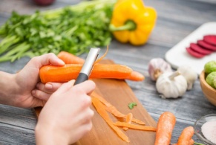Fig. 21 – Peeling  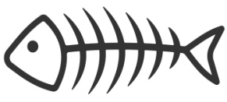  Fig. 22 – Bones  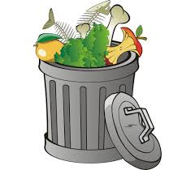  Fig. 23 – Wastage  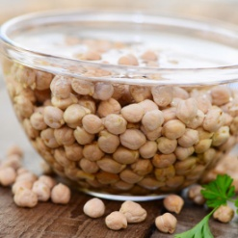  Fig. 24 – Soaking  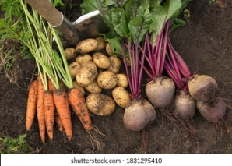  Fig. 25 – Soil on root crops  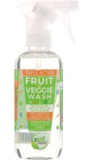  Fig. 26 – Food detergent  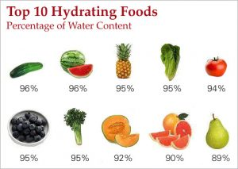  Fig. 27 – Moisture content  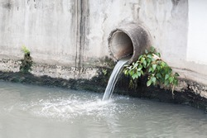  Fig. 28 – Effluent
Sources: P.J. Fellows. Food Processing Technology. Principles and Practice. Woodhead Publishing Ltd. Cambridge. 2000. P. 83-84.
Nfg
 2.1. Answer the questions to the text.
1. Which cleaning operations are there?
2. What contaminants can be found on food (fruit, root vegetables and meat)?
3. Why is it important to remove contaminants?
4. What are two big groups of cleaning methods?
5. What are the basis of choosing appropriate cleaning methods?
6. When is wet cleaning preferable?
7. What cleaning method is more cheap? Why?
8. What is recontamination? When can it take place?

2.2. Make terms by matching the words 1 – 10 with the words A – J.
1. wet |  | A | hazard | 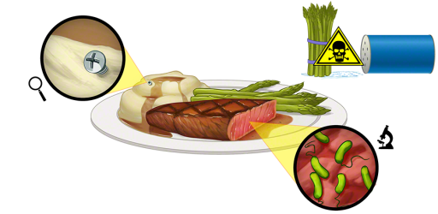  Fig. 29 – Food hazard
2. contaminating |  | B | residues
3. ultrasonic |  | C | fruits
4. root |  | D | cleaning
5. pesticide |  | E | water
6. soft |  | F | wastage
7. cleaning |  | G | content
8. mechanical |  | H | crops
9. moisture |  | I | strength
10. health |  | J | materials
What do they denote? Explain their meanings in English.

Use these word combinations in the following sentences:
- Economically, strawberries, raspberries and blackcurrants are the most important ___________ .
- It was found that ____________ at 25ºC and soaking in tap water at 30 ºC was the best combination to reduce pesticide residues.
- _____________ of wheat grain varieties influenced by moisture content and loading rate.
- Loss of __________ produced by drying results in increased concentration of nutrients in the remaining food mass.
- Onions are popular ___________, serving as a staple ingredient in many cuisines.
- More than 90% of samples including strawberries, apples and leafy greens tested positive for ___________.
- Besides causing huge economic losses, some fungal species could produce toxic metabolites in the affected sites, constituting a potential __________ for humans.
- ___________ is effective in removing firmly adherent soils from raw fruits and vegetables.

2.3. Match up the terms on the left with the definitions on the right. Make up your own sentences using these words.
1. peel | a) 1. loss by use, decay, deterioration, etc.; 2. anything thrown away.
2. discard | b) a chemical substance, usually in the form of a powder or liquid, which is used for washing things such as clothes, dishes, fruit and vegetables.
3. bulk | c) liquid discharged as waste, as from an industrial plant or sewage works.
4. delay | d) to remove (the skin, rind, outer covering, etc) of (a fruit, egg, etc).
5. wastage | e) to make, become, or be thoroughly wet or saturated, esp by immersion in a liquid.
6. moisture | f) to get rid of; throw away.
7. effluent | g) something which could be dangerous to you, your health or safety.
8. soak | h) 1. volume, size, or magnitude, especially when great;  2. the main part.
9. detergent | i) water or other liquid diffused as vapour or condensed on or in objects.
10. root vegetable | j) to get rid of as useless or undesirable things, wastes.
11. dust | k) the small hard seedlike fruit of a grass, esp a cereal plant.
12. hazard | l) matter remaining after something has been removed.
13. grains | m) 1. to put off to a later time; 2. to slow up, hinder, or cause to be late.
14. residues | n) carrot, potato, turnip or beet, cultivated for the food value of its roots .
15. dispose of | o) very small dry particles of earth or sand.

2.4. Fill in the table. Use as many word-forming affixes as possible.
Verb | Noun | Adjective | Participle I
dispose
 | residue
 |  | soft
waste
 | dust
 |  | strong
separate
 | hazard
 |  | moist
suit
 | effluent
 |  | requiring
In what way are these words connected with the topic under consideration?

2.5. Join two sentence halves. Translate the sentences.
1. Root vegetables are grown underground and include onions, | A. from contaminants by exploiting their ability to roll down an inclined, upward moving conveyor belt.
2. Classifiers use a moving stream of air to separate contaminants | B. bananas, apples, tomatoes, lettuce, pears, and grapes.
3. Round foods (peas, blackcurrants and rapeseed) are separated | C. bacteria, etc.), sugaring (to prevent their re-growth) and sealing within an airtight jar (to prevent recontamination).
4. The skin or peel of fruits and vegetables are generally higher | D. and vegetables in the water. Let soak for 15 minutes.
5. The most commonly wasted fruits and vegetables are sweet peppers, | E. are introduced to food and thus pose a food safety concern to consumers.
6. Biological hazards occur when hazardous or pathogenic organisms | F. garlic, carrots, potatoes, and beets, among others.
7. Preserving fruit by turning it into jam, for example, involves boiling (to reduce the fruit’s moisture content and to kill | G. during harvesting, formulation and processing, packaging and labelling, transportation, storage, preparation, and serving.
8. Add 1 cup of white vinegar and submerge your fruits | H. not be soaked in water.
9. Some produce such as raspberries should | I. from foods by differences in their densities.
10. Hazards may be introduced into the food supply any time | J. in antioxidants, fibre, vitamins and minerals than the flesh.

2.6. Finish the given sentences using your active vocabulary.
1. It is important to peel root vegetables because …
2. Dry cleaning is preferable when …
3. The most frequent food surface contaminants are …
4. It is important to dispose of spoiled vegetables from the whole bulk as soon as possible because …
5. If people don’t clean food before consumption it can lead to …

2.7. Describe the following picture using your active vocabulary.

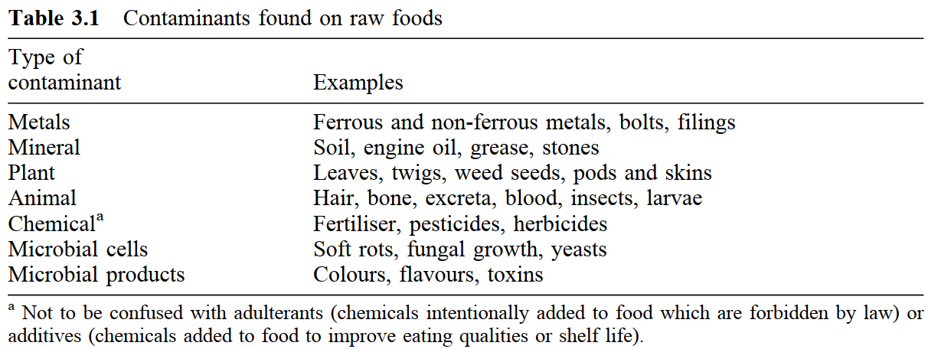

Sources: P.J. Fellows. Food Processing Technology. Principles and Practice. Woodhead Publishing Ltd. Cambridge. 2000. P. 84-85.

2.8. Put the verbs in brackets in the correct form.

Flash steam peeling
Foods (for example root crops) ______ (to feed) in batches into a pressure vessel which _______ (to rotate) at 4–6 rpm. High-pressure steam ________ (to introduce) and all food surfaces _________ (to expose) to the steam by the rotation of the vessel for a predetermined time, which _______ (to differ) according to the type of food. The high temperatures _________ (to cause) rapid heating of the surface layer (within 15–30s) but the low thermal conductivity of the product _________ (to prevent) further heat penetration, and the product ____________(not to cook). Therefore texture and colour __________ (to preserve). The pressure ________ (to release) then instantly which ________ (to cause) steam to form under the skin, and the surface of the food ‘________’ (to flash off). Most of the peeled material __________ (to discharge) with the steam, and water sprays ___________ (to need) only to remove any remaining traces. This type of peeler __________ (to gain) in popularity nowadays owing to the lower water consumption, minimum product loss, good appearance of the peeled surfaces, a high throughput with automatic control of the peeling cycle, and the production of a more easily disposable concentrated waste.

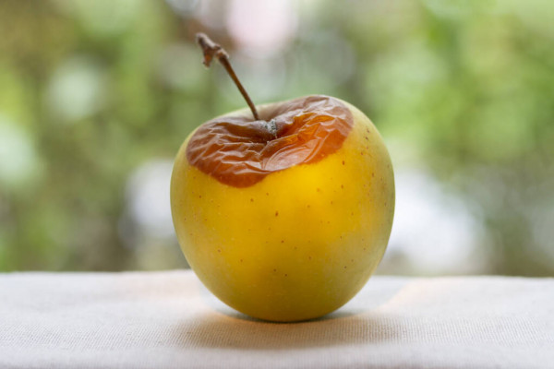
2.9. a) Study the following information about sorting. Translate the text.
Sorting is the separation of foods into categories on the basis of a measurable physical property. Like cleaning, sorting should be employed as early as possible to ensure a uniform product for subsequent Fig. 30 – Apple blemish
processing. The four main physical properties used to sort foods are size, shape, weight and colour.
The shape of some foods is important in determining their suitability for processing or their retail value. For example, for economical peeling, potatoes should have a uniform oval or round shape without protuberences. Cucumbers and gherkins are more easily packaged if they are straight, and foods with a characteristic shape (for example pears) have a higher retail value if the shape is uniform. Shape sorting is accomplished either manually or mechanically.

Sources: P.J. Fellows. Food Processing Technology. Principles and Practice. Woodhead Publishing Ltd. Cambridge. 2000. P. 84-85.

b) Study the Vocabulary below and watch the video ‘Touring a New Apple Packing Line’. Answer the following questions:
1. How are apples cleaned on the facility?
2. What equipment is used to dry apples after cleaning?
3. Are apples sorted based on their weight only?
4. What substance is used to cover apples?
5. Which operations are performed manually?
URL: https://www.youtube.com/watch?v=YAUeQHghUUs

VOCABULARY
Stacker – штабелевочная машина
Scale – весы
Bin – ящик
Wax – воск
Roller conveyer – роликовый конвейер
Even – равномерный; одинаковый
Debris – грязь
Blemish – недостаток; дефект
Lane – дорожка
Tray – поднос; поддон
Grade – сорт; марка

2.10. Sum up the main ideas of Text A.

2.11. Look at the following words and try to predict what Text B will be about.
Grinding, reduction, globules, homogenisation, chopping, cutting, slicing, emulsification, milling, homogenisation.

2.12. a) Read Text B and translate it into Russian. Divide it into logical parts, entitle them.

Text B. Size reduction
Size reduction or ‘comminution’ is the unit operation in which the average size of solid pieces of food is reduced by the application of grinding, compression or impact forces.
When applied to the reduction in size of globules of immiscible liquids (for example oil globules in water) size reduction is more frequently referred to as homogenisation or emulsification. Size enlargement is achieved by extrusion, agglomeration or forming.
Size reduction has the following benefits in food processing:
• There is an increase in the surface-area-to-volume ratio of the food which increases the rate of drying, heating or cooling and improves the efficiency and rate of extraction of liquid components (for example fruit juice or cooking oil extraction.
• When combined with screening, a predetermined range of particle sizes is produced which is important for the correct functional or processing properties of some products (for example icing sugar, spices and cornstarch).
• A similar range of particle sizes allows more complete mixing of ingredients (for example dried soup and cake mixes).
Size reduction and emulsification have little or no preservative effect. They are used to improve the eating quality or suitability of foods for further processing and to increase the range of products available. In some foods they may promote degradation by the release of naturally occurring enzymes from damaged tissues, or by microbial activity and oxidation at the increased area of exposed surfaces, unless other preservative treatments are employed.
Different methods of size reduction are classified according to the size range of particles produced:
1. Chopping, cutting, slicing and dicing:
(a) large to medium (stewing steak, cheese and sliced fruit for canning)
(b) medium to small (bacon, sliced green beans and diced carrot)
(c) small to granular (minced or shredded meat, flaked fish or nuts and shredded vegetables).
2. Milling to powders or pastes of increasing fineness (grated products > spices > flours > fruit nectars > powdered sugar > starches > smooth pastes)
3. Emulsification and homogenisation (mayonnaise, milk, essential oils, butter, ice cream and margarine).
Sources: P.J. Fellows. Food Processing Technology. Principles and Practice. Woodhead Publishing Ltd. Cambridge. 2000. P. 98-99.

 Answer the questions to the text:
- Which types of size reduction are there?
- Why is size reduction necessary during food processing?
- Does size reduction have any preservative effect?
- What advantages and disadvantages does size reduction have?
- What is the alternative term for ‘size reduction’ when we talk about the reduction in size of globules of immiscible liquids?

2.13. Make collocations.
1) immiscible | a) degradation
2) grated | b) reduction
3) promote | c) liquids
4) functional | d) size
5) average | e) properties
6) size | f) products
2.14.Find words in Text B which mean the following.
1. a substance in a physical state in which it resists changes in size and shape; opposite to liquid;
2. something that improves or promotes; advantage;
3. relationship between two things when it is expressed in numbers or amounts;
4. a very small piece or amount of it;
5. very fine white sweet condiment that is used for making buns;
6. the process of something becoming worse or weaker, or being made worse or weaker.

2.15. Join the pictures below with the following words: mixing, grating, drying, slicing, milling, freezing.
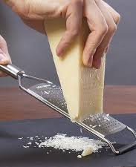 | 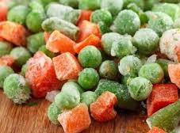 | 
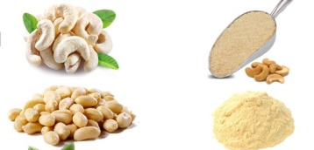 | 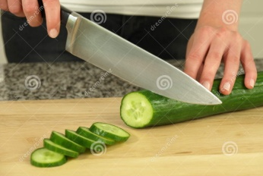 | 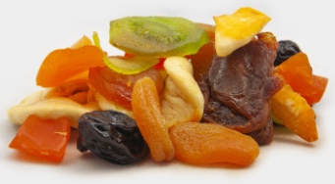

2.16. Find 10 words from the text in the puzzle.
D | C | O | M | M | I | N | U | T | I | O | N | S
R | W | E | S | U | M | I | X | I | N | G | A | M
Y | D | O | E | P | F | L | A | Z | O | P | S | O
I | F | S | R | O | J | L | F | R | P | O | X | O
N | A | P | O | W | X | I | M | J | D | S | E | T
G | R | I | N | D | I | N | G | A | Y | L | O | H
S | R | C | D | E | M | G | E | M | U | I | D | E
E | G | E | W | R | Z | G | S | J | Y | C | W | S
Z | B | S | X | T | R | E | A | T | M | E | N | T
Make your own sentences using these words.

2.17. Put questions to the words in italics.
Compression forces are used to fracture friable or crystalline foods¹; combined impact and shearing forces are necessary for fibrous foods, and shearing forces are used for fine grinding of softer foods. It is thought that foods fracture² at lower stress levels if force is applied for longer times³. The extent of size reduction, the energy expended and the amount of heat generated in the food therefore depend on both the size of the forces that are applied and the time that food is subjected to the forces. Other factors⁴ which influence the energy input are the moisture content and heat sensitivity of the food. The moisture content significantly⁵ affects both the degree of size reduction and the mechanism of breakdown in some foods⁶. For example, before milling wheat is ‘conditioned’⁷ to optimum moisture content and maize⁸ is thoroughly soaked and wet milled in order to obtain complete disintegration of the starchy material.
Sources: P.J. Fellows. Food Processing Technology. Principles and Practice. Woodhead Publishing Ltd. Cambridge. 2000. P. 100.

2.18. Make a summary of the text below.

1) Size Reduction of Solid Foods
Size reduction is a unit operation involving such activities as cutting, slicing, milling or pulping of food. It requires energy input to overcome a breaking stress. When this happens the food will break along lines of weakness resulting in release of energy and sound. So think of the last time you ate an apple, that sound that you heard is energy being given off. Where enough energy is not added to the material for breaking, it
Table 1. Types of forces used in size reduction equipment
returns to its original size. This is a characteristic of elasticity. Therefore to break materials, the energy input must overcome both the elastic stress limit and breaking stress.
The three types of forces involved in size reduction of solids are compression, impact and shear.
Compression is a grinding force, like when you pulverize cereal in a mortar.
Impact occurs when material is thrown against a surface causing it to disintegrate. For example, if you take an egg and throw it against a wall causing it to splatter, that’s an example of impact.
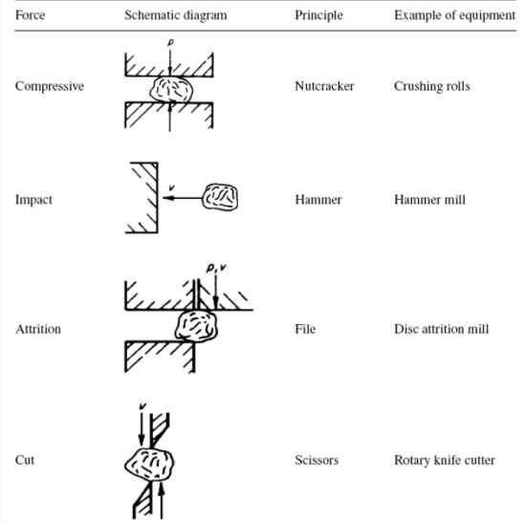
Shear is a slicing force where you have one surface sliding over another. The typical example of this is the use of knives to slice food. For example, slicing bread. All of these forces normally exists together although one usually predominates. For example, when you slice bread, the primary force is shear, but there is also compression as the knife is forced downward on the bread and impact, as the knife is first brought down to make contact with the surface of the bread.
In process industries, this operation is usually carried out in order:
a) To increase the surface area to enhance the rate of a physical or chemical process. In most of the reactions and unit operations (e.g., leaching) involving solid particles, the rate increases by increasing the area of contact between solid and second phase since the rate is proportional to the area of contact between the phases involved. In leaching, the of extraction increases because of the increased area of contact between solid and the solvent.
b) To effect the separation of two constituents in cases where one is dispersed in small isolated pockets.
c) To meet stringent specifications regarding the sizes of commercial products.
d) To accomplish intimate mixing of solids in a solid-solid operation since the mixing is more complete if the particle size is small.
e) To improve dissolution rate, solubility, binding strength and dispersion properties.
In comminution of food products, the reduction mechanism consists of deforming the food piece until it breaks or tears and such breaking may be achieved by applying diverse forces. The types of forces commonly used in food processes are compression (crushing), impact, attrition or rubbing, cutting and shearing. In a comminution operation, more than one type of force is usually acting. For example, crushing, grinding, and milling take place in powdered sugar, flour, mustard, and cocoa production.
The structure and composition of the material to be processed greatly influence the size reduction mechanisms that can be employed and the equipment used. For example, a crystalline structure (such as sugar) will break along fracture planes which require compression (using a crushing technique) to bring about size reduction. If there are no fracture planes present then new cracks must be developed using impaction. On the other hand a fibrous structure, such as vegetable matter, suggests the need for cutting or shredding. Similarly, cutting is appropriate for ductile materials such as flesh foods such as meat.
The presence of moisture can present problems in size reduction operations. Even small quantities of moisture on the surface of fine particles inevitably leads to the agglomeration of fines and therefore a size increase, although such agglomerates will be weak. More seriously, too high moisture content may lead to the rapid blockage of a mill. Equally, moisture can be useful in suppressing dust and preventing dust explosions and this is exploited in wet milling techniques for example in the milling of corn.
In a comminution operation of food materials more than one type of the above-described forces is actually present. Regardless of the uniformity of the feed material, the product always consists of a mixture of particles covering a range of sizes. Some size reduction equipment is designed to control the size of the largest particles in its products, but the fine sizes are not under control. In spite of the hardness of the comminuted materials, the above-mentioned shape of produced particles would be subjected to attrition due to inter-particle and particle—equipment contacts within the dynamics of the operation. Thus, particle angles will smooth gradually, with the consequent production of fines. In actual practice, any feed material will possess an original particle size distribution while the obtained product will end with a new particle size distribution having a whole range finer than the feed distribution.
Source: https://cwsimons.com/principles-of-size-reduction-solids

2.19. Find information about size reduction methods in liquid food (emulsification and homogenisation).

2.20. Write an essay on the topic “Advantages and Disadvantages of Size Reduction” (300-350 words).

