Unit I. Aims of Food Processing
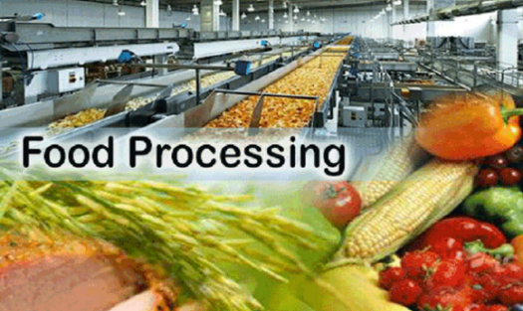 | Warm up  1.Answer the questions:  - What is the goal of food processing?  - What does food processing imply?  - What types of food processing do you know?

2. Practice the pronunciation of the following words:
Consumer-ready [kəns’juːmə ’redi], stabilize [’steɪbɪ‚laɪz], flavor [’fleɪvər], substantial [səbs’tænʃəl], dehydration [ˌdihaiˈdreiʃən], chemical [’kemɪkəl], preservatives [prɪ’zɜːʳvətɪvz], innovative [’ɪnəvətɪv], non-thermal [ˌnɒnˈθɜːməl], technology [ˌtek’nɒlədʒi], microbial [maɪk’roʊbiəl], microorganism [ˌmaɪkroʊ’ɔrgənɪzəm], vitamin [’vɪtəmɪn / ’vaɪtəmɪn], fresher-tasting [’freʃəʳ ’teɪstɪŋ], nutritive [’njuːtrɪtɪv], extensively [ɪks’tensɪvli], metabolism [mɪ’tæbəlɪzəm], pasteurization [ˌpasteuri’zation], sterilization [ˌstɛrɪlaɪˈzeɪʃən], manufacturer [mænjʊˈfæktʃərəʳ].

3. Make derivatives from the following words, using the listed suffixes and / or prefixes:
Prefixes | Consume, prevent, process,  accept, retain, thermal, desire, preserve, develop, prefer, freeze, pasteurize, common, store,  differ, grow, heat, alter, reduce | Suffixes
mis-, -un-, non-, dis-, pre-, |  | -ence, -able, -er, -age, -ment, -(a)tion, -th, -ing,

What do they denote? Explain their meanings in English. Find these derivatives in the text below.

Words and word combinations to be memorized:
Consumer-ready products | Товары, готовые к употреблению
Attribute | Характерный признак
Substantial | Существенный
Retain | Удерживать
Preservatives | Консерванты
Rapid | Быстрый
Alter | (Из)менять
Implement | Внедрять
Read the text and translate it into Russian.

Text A
Introduction to Food Processing
Food processing involves the transformation of raw animal or plant materials into consumer-ready products, with the objective of stabilizing food products by preventing or reducing negative changes in quality. Without these processes, we would neither be able to store food from time of plenty to time of need nor to transport food over long distances.  To consumers, the most important attributes of a food product are its sensory characteristics (e.g. texture, flavour, aroma, shape and colour). These determine an individual’s preference for specific products and minor differences between brands of similar products can have a substantial influence on acceptability.  A goal of food manufacturers is to develop and employ processing technologies that retain or create desirable sensory qualities or reduce undesirable changes in food due to processing.  Physical (e.g. heating, freezing, dehydration, and packaging) and chemical (e.g. reduction of pH or use of preservatives) preservation methods continue to be used extensively and technological advances to improve the efficiency and effectiveness* of these processes are being made at a rapid rate. The basis of these traditional methods involves reducing microbial growth and metabolism to prevent undesirable chemical changes in food.  Probably the most common method of food preservation used today is thermal treatment (e.g. pasteurization, sterilization). Although heating food effectively reduces levels of microorganisms such as bacteria, such processing can alter the natural taste and flavour of food and destroy vitamins. Therefore, alternative or novel food processing technologies are being explored and implemented to provide safe, fresher-tasting, nutritive foods without the use of heat or chemical preservatives. Innovative non-thermal processes for preservation of food have attracted the attention of many food manufacturers. |   Fig. 1 – Plant raw materials  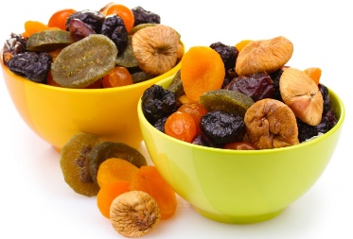  Fig. 2 – Dehydration    Fig. 3 – Thermal treatment  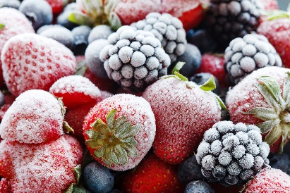  Fig. 4 – Freezing    Fig. 5 – Flavor
Source: Emerging Technologies for Food Processing. Ed. by D. Sun. Elsevier Ltd. 2005. P. 3-4.

*Mind the difference between the words ‘efficiency’ and ‘effectiveness’

We use efficient to describe something or someone that works in a quick and organized way.
We use effective to describe something that gives you the results you want.

Thus Effectiveness is about doing the right task, completing activities and achieving goals. Efficiency is about doing things in an optimal way, for example doing it the fastest or in the least expensive way. It could be the wrong thing, but it was done optimally. Efficiency has to do with economy, process and output while effectiveness is dealings with outcomes i.e. impact or effect achieved as a result what was performed.
Sources:https://www.researchgate.net/post/What_is_the_difference_between_efficiency_and_effectiveness; https://dictionary.cambridge.org/ru/efficient-or-effective
 1.1. Answer the questions to the text.
1. Why should we process food?
2. What are the most important characteristics of a food, which have an influence on the food choices?
3. What is one of the main aims of food manufacturers today?
4. Where are the main preservation methods?
5. Why can we store food longer after processing?

1.2. Agree or disagree with the following statements. If you disagree, give your reasons.
1. Food processing involves the transformation of only animal and plant materials, aquatic food products are not processed.
2. The quality of food deteriorates over time.
3. Food color is as important for consumers, as its taste and aroma.
4. Freezing belongs to chemical processing methods.
5. Food processing technologies are developing very fast nowadays.
6. Food pH cannot be altered during processing.
7. Thermal processing destroys vitamins.
8. Food processing helps to suppress the spread of microbes in food.
9. It is impossible to store food for a long time without preservatives.
10. Thermal food processing is one of the oldest methods used by people to preserve food quality.
 1.3. Match up the terms on the left with the definitions on the right.
1. quality | a) substances that you need in order to remain healthy, which are found in food or can be eaten in the form of pills.
2. to prevent | b) a very small living thing which you can only see if you use a microscope.
3. vitamins | c) taste perceived in food or liquid in the mouth
4. fresh | d) the process of water removal, often used in order to preserve food.
5. flavour | e) showing resemblance in qualities, characteristics, or appearance; alike but not identical.
6. metabolism | f) to ensure that something does not happen.
7. sensory | g) the process of heating beverages, such as milk, beer, wine, or cider, or solid foods, such as cheese or crab meat, to destroy harmful or undesirable microorganisms or to limit the rate of fermentation by the application of controlled heat.
8. dehydration | h) relating to or caused by heat or by changes in temperature.
9. microorganism | i) the way that chemical processes in your body cause food to be used in an efficient way, for example to make new cells and to give you energy.
10. to implement | j) 1. a particular product or a characteristic that serves to identify a particular product; 2. a trade name or trademark.
11. thermal | k) to make or become different in some respect; change.
12. pasteurization | l) 1. any of the features that make something what it is; characteristic element; attribute; 2. the degree of excellence which a thing possesses.
13. to alter | m) to carry out; put into action; perform.
14. similar | n) relating to the physical senses.
15. brand | o) picked or produced recently, not been preserved, for example by being frozen or put in a tin.

1.4. Replace the words in italics by their synonyms (words and word combinations) from Text A.
1. Drying inhibits the growth of bacteria, yeasts, and mold through the removal of water.
2. Food odor is initially detected via the nose through sniffing of volatile components.
3. Proper heating and reheating will kill foodborne bacteria. However, some foodborne bacteria produce poisons or toxins that are not destroyed by high cooking temperatures if the food is left out at room temperature for an extended period of time.
4. Heat can also dramatically change both the texture and flavor of food.
5. Whole foods and those that are only minimally treated, like frozen vegetables without any sauce, tend to be more healthy.
6. Foods can be considered as a medium for microbial development.
7. Salt, sodium nitrite, spices, vinegar, and alcohol have been used to save foods for centuries. Sodium benzoate, calcium propionate, and potassium sorbate are used to curb microbial growth that causes spoilage and to slow changes in color, texture, and flavor.
8. Sodium nitrite/nitrate is the chemical substance used in processed meats and may have cancer-causing effects, especially if consumed in high amounts.
9. Cooling and chilling are used to reduce the temperature of the food from one processing temperature to another or to a required storage temperature (below 0ºC).
10. During wet heat treatment, as in blanching, boiling and canning of vegetables and fruits, there is a considerable loss of low molecular weight carbohydrates.
The basic purpose for the thermal processing of foods is to reduce or destroy microbial activity, reduce or destroy enzyme activity and to produce physical or chemical changes to make the food meet a certain quality standard. e.g. gelatenization of starch & denaturation of proteins to produce edible food.

1.5. Match up the words in the right and the left columns to make expressions. Make up your own sentences using these expressions for your partner to translate.
1. food | a. manufacturer
2. non-thermal | b. changes
3. to destroy | c. qualities
4. microbial | d. preservation
5. sensory | e. materials
6. raw | f. vitamins
7. chemical | g. food processing technologies
8. novel | h. growth

1.6. Put the questions to the words and word groups in italics.
Processing¹ can also help to inhibit or destroy pathogens² (disease-causing organisms) that may contaminate food³. Preservation techniques such as refrigeration, fermentation, dehydration, and the use of salt, sugar, or chemical preservatives⁴ can slow or stop the growth of pathogens. Heat processes, such as pasteurization and cooking, are used to destroy⁵ them.
Source: https://www.foodsystemprimer.org/food-processing


1.7. Insert the missing words using appropriate derivatives.
Food Processing in the USA  The food industry is one of the United States’ largest _____________ sectors, accounting for more than 10 percent of all shipments. The processed food ______ has experienced steady growth over the 1997-2004 period. In 2004, the value of food shipments reached $ 511.5 billion, an increase of 21 percent versus 1997.  Demand for ________ food products is less affected by ________ upswings and downswings since food is a _________.  Any food product _________ additional work is referred to as a processed product, regardless of whether the work is minor, such as for ______ fruit, or more complex, such as for snack foods. Of the sub sectors comprising the food manufacturing industry, the largest four are: meat products; dairy products; grain and oilseed milling, and other food, making up 66 percent of total shipment values. Other sectors __________ fruit and vegetable preserving and specialty food manufacturing, which accounted for 10 percent, bakeries and tortilla manufacturing (10 percent), animal food (6 percent), sugar and confectionery products (5 percent) and seafood products (2 percent).  Food manufacturers are _______ concerned with implementing greater automation in the manufacturing process. Increasing use of automation and advances in technology are increasing _________ in the food manufacturing industry. In particular, automation is being __________ used in packaging, inspection and inventory control.  The U.S. processed food industry is a major participant in the global economy. More than a third of the world’s top 50 food and beverage processing firms are _____________ in the United States. | manufacture  industrious  process  economy  necessary  requirement  can  including  increase  product  heavy  headquarters

Source: http://www.invest-in-usa.org/industries/3/food-processing

1.8. Translate small texts containing the words from active vocabulary.
1. Processed foods are any food that has gone through chemical, mechanical or physical processing in the processing industries or at home and which has been altered from its natural state to a new state. These foods include frozen, pasteurized, fried, condensed, dried, dehydrated, canned and homogenized food. The food processing industry has an important role to play in linking the farmers to the final consumers in the domestic as well as the international markets.  2. The consumer preference for processed food products are influenced by physiological, psychological and sociological factors. Nearly one third of the consumers are purchasing processed food products once in a week. Easy availability, taste, convenience and quality were the main factors influencing purchase of processed food products by consumers.  3. Food processing can affect the nutritional quality of foods in both ways: it can enhance it, for instance by adding components that were not present, like vitamin D (through ‘fortification’), or by lowering fat, salt or sugar. It can also cause some fibre and vitamins and minerals to be lost, for example through excessive refining, heating or freezing.  4. Processing and packaging technologies help to answer modern day time-constraints by providing a range of convenient foods: ready meals, bagged salads, sliced and canned fruits and vegetables that take little time to prepare and can be consumed “on the go”.  5. Food processing can decrease the cost of foods. For example, frozen vegetables have a similar nutritional value as fresh ones, but at a lower price, as they have already been prepared, do not contain inedible parts, can be bought in bulk, and can last longer. This way, processing increases the shelf life of food, and decreases the amount of waste, reducing thereby the overall costs of food production. |   Fig. 6 – Canned caviar    Fig. 7 – Purchase  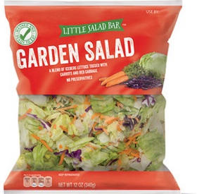 Fig. 8 – Bagged salad  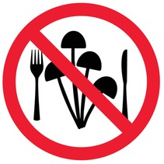  Fig. 9 – Inedible food
Source: https://www.cabi.org/nutrition/abstract/20193074633
1.9. Study the vocabulary below and watch the video ‘Why Do We Process Foods?’ by Donald G. Mercer, PhD, P.Eng., Department of Food Science, University of Guelph. 2016.
URL: https://www.youtube.com/watch?v=qSe31Tc8rtI

Vocabulary
Outline – план  Deterioration - снижение качества; ухудшение  Supply – предложение  Demand – спрос  Spatial – территориальный; пространственный  Famine – голод  Meet demands – удовлетворять спрос  Hemisphere – полушарие  Align – выравнивать; налаживать; выровнять  Edibility - пригодность к употреблению в пищу; съедобность  Harvest – собирать урожай  Starch – крахмал  Gelatinize – загустевать  Digest – переваривать (о пище)  Shelf life – срок годности  Appealing – привлекательный  Overabundance – излишек; переизбыток  Rotten – испорченный; гнилой  Variety – разнообразие  Convenient – удобный  Noodles – лапша  Stir – перемешивать  Accomplish – достигать; доводить до конца  Disposable income – располагаемый доход  Spending pattern – структура расходов  Host of – множество  Impact – воздействие; влияние  Estimates – оценочные показатели  Increment – интервал; промежуток  Spices – пряности; специи  Impoverishment – снижение запасов  Anticipate – прогнозировать; предвидеть  Give an edge – давать преимущество  Competitor – конкурент  Transparent – прозрачный  Hot button – больная тема; животрепещущий вопрос  Leverage – эффективно использовать  Cater – снабжать продуктами  Ply – крейсировать; перевозить; плавать  Gourmet – деликатессный  Mold – плесень  Rodent – грызун  Induce – вызывать; стимулировать  Ambient temperature – температура окружающего воздуха; комнатная температура  Oxidative rancidity - прогорклость, вызванная окислительными процессами  Off-flavor - несвойственный продуктам вкус; посторонний привкус  Enzyme – фермент  Catalyst – катализатор  Cauliflower – цветная капуста  Nitrogen – азот  Plum – слива; Prune – чернослив  Beverage – напиток  Maple syrup – кленовый сироп  Drying chamber – сушильная камера  Adjust – регулировать  Water binding – связывание воды  Intermediate moisture foods - продукты питания с умеренным обезвоживанием  Threshold level – пороговый уровень  Spoilage – порча товара  Fermentation – брожение |   Fig. 10 – Food deterioration  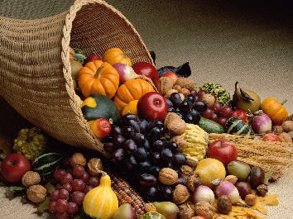  Fig. 11 – Harvest  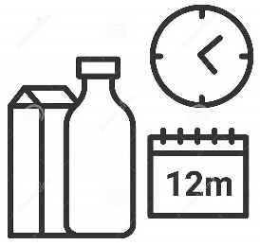  Fig. 12 – Shelf life  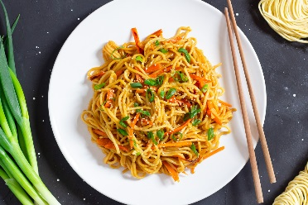  Fig. 13 – Noodles  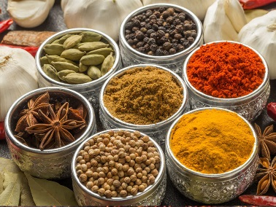  Fig. 14 – Spices  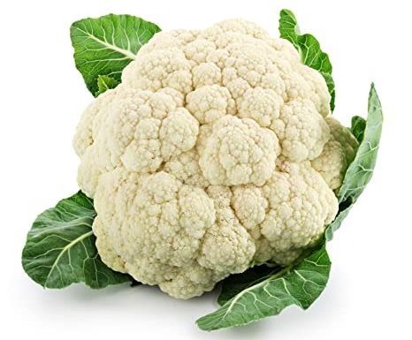  Fig. 15 – Cauliflower  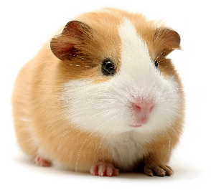  Fig. 16 – Rodent    Fig. 17 – Beverage
Answer the questions to the video:
- Why do people process food?
- What are the impacts of demographics on food preparation?
- Which changing consumer trends are mentioned?
- What are the main causes of food deterioration?
- How can we reduce the rate of chemical reactions?
- Which food preservation techniques are mentioned in the video? How do they work?
- Which products are mentioned in the video?
Describe the pictures demonstrated in the video. How are they connected with food processing?

a) Spatial demand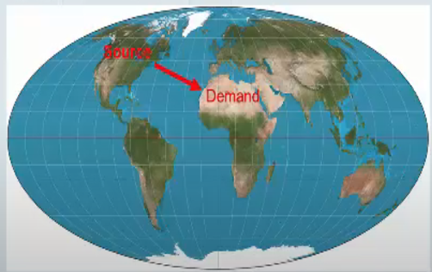 | b) Causes of food deterioration  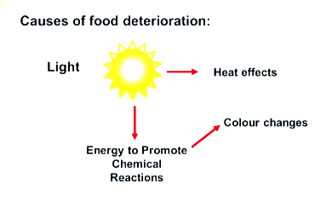
c) Presence of water  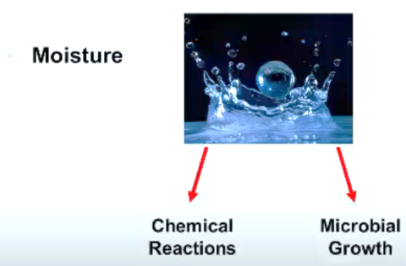 | - Food preservation  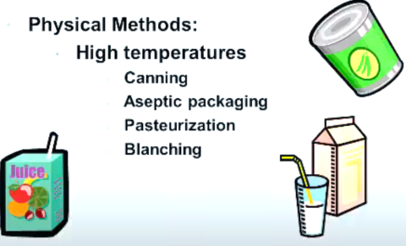

Retell the script of the video using the following pictures:
- Food diversity   | - Shelf life   | - Food spoilage  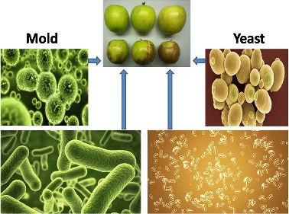
- Freezing  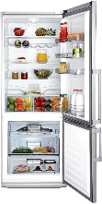 | - Oxygen and nitrogen  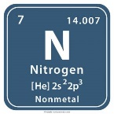 | - Heating  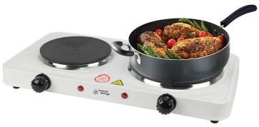

1.10. Sum up the main ideas of Text A and the video (Ex. 1.9).

1.11. Look at the following words and try to predict what Text B will be about.
Pasteurization, degradation of vitamins, bacterial inactivation, heat exchanger, sterilization, retort, blanching, par boiling, extended storage, overprocessing.

1.12. a) Read Text B and translate it into Russian.

Text B. Thermal Food Preservation Techniques
(Pasteurization, Sterilization, Canning and Blanching)

The use of heat for thermal processing to inactivate microorgaisms has been one of the most widely used methods of food preservation for more than a century and has contributed significantly to the nutritional well-being of much of the world’s population.
The processing technologies most commonly used in the food industry consist of in-line pasteurization and sterilization of liquids through the use of heat exchangers and hold tubes prior to filling into containers, and in-container pasteurization or sterilization (canning) consisting of heating filled and sealed food containers in pressurized retorts (autoclaves or ‘pressure cookers’).
Blanching is a relatively mild form of heat treatment applied to fresh foods prior to preservation processes to release entrapped air and inactivate enzymes.
Thermal processing in the food industry covers the broad area of preservation technology in which heat treatments are used to inactivate microorganisms to accomplish either commercial sterilization or pasteurization. Sterilization of foods is normally accomplished by what is commonly called ‘canning’ to preserve the safety and wholesomeness of ready-to-eat foods over long terms of extended storage at normal room temperature. These are known as shelf-stable foods.
Pasteurization is normally used to extend the limited shelf-life of refrigerated foods. Both processes make use of heat treatments to inactivate microorganisms. However, they differ widely with respect to the classification or type of microorganism targeted, the range of temperatures that must be used, and the type of equipment systems capable of achieving such temperatures.
Food canning is most often referred to as thermal processing within the food industry. Thermal processing consists of heating food containers in pressurized retorts at specified temperatures for prescribed lengths of time. These process times are calculated on the basis of achieving sufficient bacterial inactivation (lethality) in each container to assure food safety to the consuming public and to ensure that the probability of spoilage will be less than some minimum. Associated with each thermal process is always some degradation of heat-sensitive vitamins and other quality factors that is undesirable. Because of these quality and safety factors, great care is taken in the calculation of process times and in the control of time and temperature during processing to avoid either under- or overprocessing.
Blanching is a relatively mild form of heat treatment consisting of a few minutes of exposure to boiling water or atmospheric steam, and is not a food preservation process. It is normally applied to fresh foods (fruits and vegetables) prior to further processing. In food processing, blanching is usually the last step in the sequence of raw material preparation (washing, sorting, cutting, chopping, dicing, slicing, etc.). It is often needed to release entrapped air and inactivate enzymes prior to down-stream preservation processes such as drying, freezing, and canning. In the food process industry, blanching is normally accomplished by having the prepared raw food material travel on a convey or through an atmospheric steam tunnel or hot water bath.
In the context of food preparation in cooking, blanching is an alternative term for par boiling. It is a heating process wherein the food is plunged into boiling water for just a few minutes and then quickly immersed in cold water (shocked) to immediately halt the cooking process. The meaning of blanching is ‘to whiten’, but this is not always the purpose of blanching in cooking. Food is often blanched to soften it, or to partly or fully cook it, or to remove a strong undesirable taste (for example, of bacon, cabbage, or onions).
Source: Conventional and Advanced Food Processing Technologies. Ed. by S. Bhattacharya. Wiley Blackwell. 2015. P. 127-128.

Vocabulary
In-line – поточный  Sealed – герметичный  Retort – автоклав  Entrapped – уловленный; захваченный  Wholesomeness – качественное состояние  Shelf-stable - пригодный для длительного хранения  Canning - консервирование  Target - направлять усилия на борьбу с чем-л.  Prescribed - предписанный; предусмотренный  Lethality – поражающее действие  Heat treatment – тепловая обработка  Sequence – последовательность  Dice – нарезать в форме кубиков  Plunge – окунать; погружать  Immerse - погружать что-л. в жидкость | 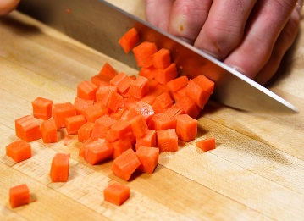  Fig. 18 – Dicing.  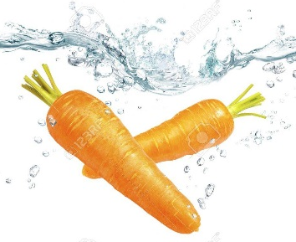  Fig. 19 – Plunge / immerse.

1.13. Find the synonyms in column 2 for the words in column 1.
1. airproof | a. fluid
2. prior to | b. sealed
3. dice | c. before
4. liquid | d. par boiling
5. ensure | e. autoclave
6. retort | f. plunge
7. immerse | g. guarantee
8. blanching | h. cut

1.14. Use the words in exercise 1.13 to fill in the gaps. Translate the sentences.
1. Vegetables should be cooled quickly and thoroughly to stop the cooking process immediately after blanching. To do this, _________ the vegetables into a large bowl of cold water, 60 degrees Fahrenheit or below.
2. Retort foods are produced by placing pre-cooked food in a pouch or container. This is hermetically __________ and heated under high pressure at around 120°C (250°F), a sterilization process that permits storage at room temperature for about three months to one year without preservatives.
3. Common cooking __________s include water, stock, and wine.
4. ___________ is a cooking process in which a food, usually a vegetable or fruit, is scalded in boiling water, removed after a brief, timed interval, and finally plunged into iced water or placed under cold running water (known as shocking or refreshing) to halt the cooking process.
5. A food safety management system (FSMS) is not only a legal requirement, but a helpful tool to __________ safe practices are followed within food production company.

1.15. Find the words from the text which correspond to the following pictures:

a) Noun   | b) Participle II  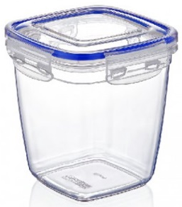 | c) Verb  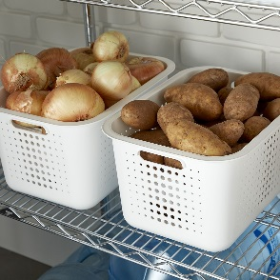
- Participle I  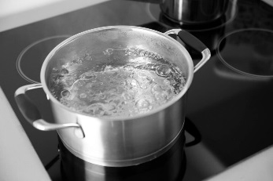 | - Verb  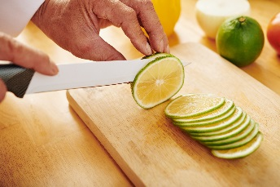 | f) Gerund  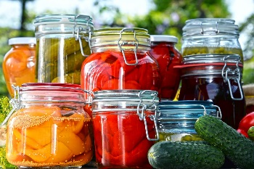

1.16. Find 8 words from the Active Vocabulary in the puzzle.
E | S | E | A | L | E | D | W | G | L | A | C | L
Q | L | S | L | E | A | X | C | E | M | N | W | A
M | O | E | P | T | B | H | I | L | R | W | J | H
A | R | Q | C | H | S | I | M | M | E | R | S | E
K | S | U | A | A | J | G | J | R | T | Q | E | V
I | Y | E | D | L | X | A | P | D | O | U | N | A
С | A | N | N | I | N | G | K | C | R | L | J | U
N | B | C | W | T | A | R | G | E | T | E | O | G
D | V | E | F | Y | U | T | C | D | I | C | E | P
1.17. Fill in the gaps with appropriate derivatives.

Food Chilling & Freezing  The ________ of food by refrigeration is based on a very general principle in physical chemistry: molecular _________ is depressed and consequently chemical reactions and biological processes are slowed down at low temperature . In contrast to heat ________, low temperature practically does not destroy microorganisms or enzymes but merely depresses their _______. Therefore:  ● Refrigeration retards ________ but it cannot improve the initial quality of the product, hence the importance of assuring particularly high microbial quality in the ________ material  ● Unlike thermal sterilization, refrigeration is not a method of ‘ permanent preservation ’ . Refrigerated and even __________ foods have a definite ‘ shelf life ’ , the length of which depends on the storage temperature  ● The preserving action of cold exists only as long as low temperature is maintained, hence the importance of maintaining a ___________ ‘ cold chain ’ all along the commercial life of the product  ● Refrigeration must often be combined with other preservation processes (the ‘ hurdle ’ principle). ________ ice, snow, cold nights and cool caves have been used for preserving food since pre-history.  Food preservation at low temperature comprises two distinct processes: chilling and freezing. Chilling is the ___________ of temperatures in the range of 0°C to 8°C, i.e. above the freezing point of the food, while freezing uses temperatures well below the freezing point, ___________ below 18°C. The difference between the two processes goes beyond the difference in temperature. The stronger preserving action of freezing is due not only to the lower temperature but also and mainly to the ___________ of water activity as a result of conversion of part of the water to ice.  The use of refrigeration in the food industry is not limited to preservation. Refrigeration is applied for a number of other purposes such as hardening (butter, fats), freeze concentration, freeze ___________, air conditioning including air dehumidification and cryomilling. | preserve  mobile  treat  act  spoil  start  freeze  rely  nature  apply  convention  press  dry
Source: Food Process Engineering and Technology. Elsevier Inc., 2009. P. 391-392.

1.18. Fill in the blanks with the verb in the correct form.
1. The cold temperatures of a domestic freezer (-18°C) ______ (to delay) chemical reactions within foods and put any bacteria that may be present on pause. The bacteria _______ (to be) still alive, but they stop growing or producing toxins, in effect pausing reactions.
The important thing to remember is that because the bacteria ____________ (to kill), they may be revived as the food _______ (to defrost). Make sure the food never ___________ (to enter) the Danger Zone because the bacteria may grow and make you ill. This is why you should defrost food within a fridge.
It is also the reason why we advise foods ___________ (can, refreeze) if they __________ (to defrost) accidentally, unless they are first cooked. If the food ___________ (to defrost) it must be cooked before being eaten to be safe. Once defrosted, foods should be consumed within 24 hours.
Source: https://www.food.gov.uk/safety-hygiene/chilling

1.19. Study the table below and discuss the characteristics of freezing and chilling.
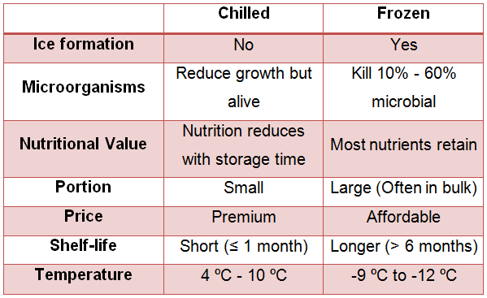
Source: Taylor’s University Website. URL: http://coldfoodpreservationmethods.blogspot.com/2015/06/blog-post_1.html

Prepare a short report about advantages and disadvantages of such physical ways of food processing as blanching, canning, pasteurization, freezing, chilling, etc.

1.20. Make a presentation about physical ways of food processing.

