Unit III. Essential inorganic nutrients
Warm up
1. Answer the questions:
1. What are minerals?
2. Can minerals be the source of energy?
3. What is the function of minerals in the human organism?

2. Practice the pronunciation of the following words:
Inorganic [ˌɪnɔːˈɡænɪk], constitute [ˈkɒnstɪtjuːt], weight [weɪt], amount [əˈmaʊnt], require [rɪˈkwaɪə], trace [treɪs], diverse [daɪˈvɜːs], include [ɪnˈkluːd], contraction [kənˈtrækʃən], transmission [trænzˈmɪʃən], completely [kəmˈpliːtli], leach [liːtʃ], subsequently [ˈsʌbsəkwəntli], discard [dɪsˈkɑːd].

3. Read and guess the meaning of the following words:
calcium [ˈkælsiəm], magnesium [mæɡˈniːziəm], sulfur [ˈsʌlfə], sodium [ˈsəʊdiəm], chloride [ˈklɔːraɪd], potassium [pəˈtæsiəm], iron [ˈaɪən], zinc [zɪŋk], copper [ˈkɒpə], manganese [ˈmæŋɡəniːz], iodine [ˈaɪədiːn ], selenium [səˈliːniəm], fluoride [ˈflʊəraɪd], molybdenum [məˈlɪbdənəm], chromium [ˈkrəʊmiəm], cobalt [ˈkəʊbɔːlt].

Words and word combinations to be memorized:
Complex compounds | сложные соединения
Inorganic elements | неорганические элементы
Salts | соли
To constitute | составлять
Body weight | масса тела
One-half | одна вторая
One-quarter | четверть
Are divided into | подразделяются на
Major minerals | основные минералы (макроэлементы)
In amounts of | в количестве
Trace minerals | микроэлементы
Diverse functions | разнообразные функции
Muscle contraction | сокращение мышц
Processed food | обработанные пищевые продукты
Food preparation | приготовление пищи
Can be burned | может быть усвоен
Remain unchanged | оставаться в неизменном виде

 Read the text, translate it into Russian.

Text A. Minerals
Unlike the complex organic compounds (carbohydrates, lipids, proteins, vitamins), minerals are simple inorganic elements often in the form of salts in the body that are not themselves metabolized, nor are they a source of energy. Minerals constitute about 4 to 6 percent of body weight—about one-half as calcium and one-quarter as phosphorus (phosphates), the remainder being made up of the other essential minerals that must be derived from the diet. Minerals not only impart hardness to bones and teeth but also function broadly in metabolism.
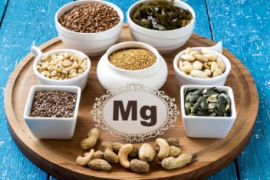 | As nutrients, minerals are traditionally divided into two groups according to the amounts present in and needed by the body. The major minerals (macrominerals) those required in amounts of 100 milligrams or more per day are calcium,
phosphorus (phosphates), magnesium, sulfur, sodium, chloride, and potassium.
The trace elements (microminerals or trace minerals), required in much smaller amounts of about 15 milligrams per day or less, include iron, zinc, copper, manganese, iodine (iodide), selenium, fluoride, molybdenum, chromium, and cobalt (as part of the vitamin B₁₂ molecule).
Minerals have diverse functions, including muscle contraction, nerve transmission, blood clotting, immunity, the maintenance of blood pressure, and growth and development.
The levels of different minerals in foods are influenced by growing conditions (e.g., soil and water composition) as well as by how the food is processed. Minerals are not destroyed during food preparation; in fact, a food can be burned completely and the minerals (ash) will remain unchanged. However, minerals can be lost by leaching into cooking water that is subsequently discarded.
Source: https://www.britannica.com/science/human-nutrition

 3.1. Expand on the following points.
- Major minerals.
- Trace minerals.

3.2. Complete the chart listing the names of the minerals.

Macrominerals | Microminerals
1. | 1.
2. | 2.
3. | 3.
4. | 4.
5. | 5.
6. | 6.
7. | 7.
 | 8.
 | 9.
 | 10.

3.3. Answer the questions to the text.
1. What influences the level of different minerals in foods?
2. Are minerals destroyed during food preparation?
3. What might happen to minerals contained in foods while cooking?

 3.4. Match up the words in the right and the left columns to make expressions. Make up your own sentences using them.
1. organic | a. compounds
2. inorganic | b. hardness
3. essential | c. the diet
4. derived from | d. elements
5. impart | e. in metabolism
6. function | f. by the body
7. needed | g. minerals

3.5. Complete the gaps with the words from Text A.
trace, diet, foods, minerals, calcium, groups, iron, sources

What do minerals do in the body?
1._______work to regulate many body processes. Sodium and potassium are important to nervous system function. The 2._______mineral selenium works with vitamin E as an antioxidant, preventing cells from being damaged by oxygen.
Where are minerals found in foods?
All of the food groups have 3.________rich in minerals. For example, milk is a good source of 4.________, and red meat is rich in iron and zinc. Fruits and vegetables are good sources of potassium. Whole grains are rich in magnesium and selenium. Nuts and seeds are sources of copper and manganese. It’s important to eat a variety of foods from each of the food 5.________in order to get all of the minerals in your 6.________.
Are animal products better sources of minerals than plant foods? Certain minerals, such as 7.________and zinc, tend to be better absorbed by the body from animal foods than from plant foods. Phytate and oxalate, which are found mainly in whole grains, vegetables, and legumes, reduce absorption of some minerals (Gibson, Bailey, Gibbs, & Ferguson 2010). Still, plant foods are important 8.________of many minerals, so diets rich in a variety of plant foods can provide adequate amounts of minerals.

3.6. Replace the formulas in italics by the corresponding words from Text A.

1. During Ca ingestion, factors such as calcitonin might attenuate bone resorption, while bone calcium deposition continues.
2. The different soda, magnesia and P4 pentoxide levels can be related to the use of a different soda source.
3. As is the case for calcium, correction of K deficiency may not be possible until the serum magnesium level is normalized.
4. This happened to a man with eczema and asthma who was treated with a low potency of SO₂ which improved both symptoms.
5. There were no significant changes in the patients' mean weight and serum creatinine and Na concentrations throughout the trial.

3.7. Unjumble the words.
Model: | Gnirio → origin

1. ufruls | 5. derolihc
2. precop | 6. dusimo
3. nemulise | 7. nagesamen
4. limacuc | 8. sumaginem

 3.8. Scan the text and choose the appropriate article from the given options.
Can large amounts of minerals be harmful?
With minerals, as with many things in life, more is not necessarily better. Many minerals can be toxic in large doses, with side effects ranging from constipation to liver and kidney damage. Too much sodium may contribute to high blood pressure in some individuals. There are recommendations for a / the / - maximum intakes for - / the most minerals. Excessive mineral intake usually comes from high-dose supplements. That’s why most people should choose to consume no more than the / - / a Tolerable Upper Limit (UL) for a / - / the mineral each day. If you currently are taking medications, you should check with your doctor or pharmacist to see if there are any reasons that you shouldn’t take - / the / a mineral supplement. Also, ask if you need to adjust the / a / - timing of your mineral supplements and other medications. Some minerals can interfere with how well the / - / a medication works in a / - / the body. Alternatively, some medications can interfere with how well a / - / the body uses a / - / the mineral. That’s why it’s important to ask your doctor or pharmacist before taking - / a / the mineral supplement.

3.9. Derive from the given words.
Verb | Noun | Adjective | Adverb
constitute
 |  | simple
function
 |  | essential
require
 |  |  | broadly
 | composition
 |  |  | completely
 |  | different
 | contraction
impart
 | development
 |  |  | traditionally
 | preparation
derive
 | maintenance

3.10. a) Scan the two tables below listing minerals, what they do in the body (their functions), and their sources in food;

Macrominerals
Major minerals
Mineral | Function | Sources
Sodium | Needed for proper fluid balance, nerve transmission, and muscle contraction | Table salt, soy sauce; large amounts in processed foods; small amounts in milk, breads, vegetables, and unprocessed meats
Chloride | Needed for proper fluid balance, stomach acid | Table salt, soy sauce; large amounts in processed foods; small amounts in milk, meats, breads, and vegetables
Potassium | Needed for proper fluid balance, nerve transmission, and muscle contraction | Meats, milk, fresh fruits and vegetables, whole grains, legumes
Calcium | Important for healthy bones and teeth; helps muscles relax and contract; important in nerve functioning, blood clotting, blood pressure regulation, immune system health | Milk and milk products; canned fish with bones (salmon, sardines); fortified tofu and fortified soy milk; greens (broccoli, mustard greens); legumes
Phosphorus | Important for healthy bones and teeth; found in every cell; part of the system that maintains acid-base balance | Meat, fish, poultry, eggs, milk, processed foods (including soda pop)
Magnesium | Found in bones; needed for making protein, muscle contraction, nerve transmission, immune system health | Nuts and seeds; legumes; leafy, green vegetables; seafood; chocolate; artichokes; "hard" drinking water
Sulfur | Found in protein molecules | Occurs in foods as part of protein: meats, poultry, fish, eggs, milk, legumes, nuts

Trace minerals (microminerals)
The body needs trace minerals in very small amounts. Note that iron is considered to be a trace mineral, although the amount needed is somewhat more than for other microminerals.

Trace minerals
Mineral | Function | Sources
Iron | Part of a molecule (hemoglobin) found in red blood cells that carries oxygen in the body; needed for energy metabolism | Organ meats; red meats; fish; poultry; shellfish (especially clams); egg yolks; legumes; dried fruits; dark, leafy greens; iron-enriched breads and cereals; and fortified cereals
Zinc | Part of many enzymes; needed for making protein and genetic material; has a function in taste perception, wound healing, normal fetal development, production of sperm, normal growth and sexual maturation, immune system health | Meats, fish, poultry, leavened whole grains, vegetables
Iodine | Found in thyroid hormone, which helps regulate growth,development, and metabolism | Seafood, foods grown in iodine-rich soil, iodized salt, bread, dairy products
Selenium | Antioxidant | Meats, seafood, grains
Copper | Part of many enzymes; needed for iron metabolism | Legumes, nuts and seeds, whole grains, organ meats, drinking water
Manganese | Part of many enzymes | Widespread in foods, especially plant foods
Fluoride | Involved in formation of bones and teeth; helps prevent tooth decay | Drinking water (either fluoridated or naturally containing fluoride), fish, and most teas
Chromium | Works closely with insulin to regulate blood sugar (glucose) levels | Unrefined foods, especially liver, brewer's yeast, whole grains, nuts, cheeses
Molybdenum | Part of some enzymes | Legumes; breads and grains; leafy greens; leafy, green vegetables; milk; liver
Other trace nutrients known to be essential in tiny amounts include nickel, silicon, vanadium, and cobalt.
Source: https://www.britannica.com/science/human-nutrition
 b) On the part of a nutritional consultant prepare nutrition recommendations for people suffering:
- Heart diseases;
- Diabetes;
- Blood circulation diseases;
- Stomach problems;
- Nervousness;
- Musculoskeletal disturbance;
- Cataract;
- Hepatitis;
- Polio.
3.11. a) Read through the key words and phrases, try to predict what Text B will be about;

The most critical nutrient; temperature regulation; large molecules; a solvent; a lubricant; a protective cushion; the flow; electrolyte; intracellar; extracellar; 50-70 percent; a constituent; metabolism; excretion; dehydration; fluid; intake.

b) Skim Text B and say whether your guesses were right.

Text B. Although often overlooked as a nutrient, water is actually the most critical nutrient of all. Humans can survive weeks without food but only a matter of days without water.
Water provides the medium in which nutrients and waste products are transported throughout the body and the myriad biochemical reactions of metabolism occur. Water allows for temperature regulation, the maintenance of blood pressure and blood volume, the structure of large molecules, and the rigidity of body tissues. It also acts as a solvent, a lubricant (as in joints), and a protective cushion (as inside the eyes and in spinal fluid and amniotic fluid). The flow of water in and out of cells is precisely controlled by shifting electrolyte concentrations on either side of the cell membrane. Potassium, magnesium, phosphate, and sulfate are primarily intracellular electrolytes; sodium and chloride are major extracellular ones.
Water makes up about 50 to 70 percent of body weight, approximately 60 percent in healthy adults and an even higher percentage in children. Because lean tissue is about three-quarters water, and fatty | 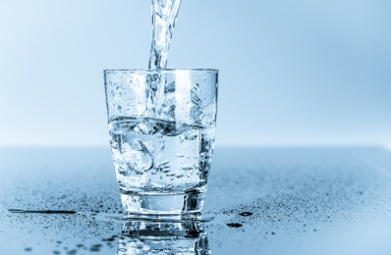
tissue is only about one-fifth water, body composition the amount of fat in particular determines the percentage of body water.
In general, men have more lean tissue than women, and therefore a higher percentage of their body weight is water. Water is consumed not only as water itself and as a constituent of other beverages but also as a major component of many foods, particularly fruits and vegetables, which may contain from 85 to 95 percent water. Water also is manufactured in the body as an end product of metabolism. About 2.5 litres (about 2.6 quarts) of water are turned over daily, with water excretion (primarily in urine, water vapour from lungs, sweat loss from skin, and feces) balancing intake from all sources. Because water requirements vary with climate, level of activity, dietary composition, and other factors, there is no one recommendation for daily water intake.
 | However, adults typically need at least 2 litres (8 cups) of water a day, from all sources. Thirst is not reliable as a register for dehydration, which typically occurs before the body is prompted to replace fluid.
Therefore, water intake is advised throughout the day, especially with increased sweat loss in hot climates or during vigorous physical activity, during illness, or in a dehydrating situation such as an airplane flight.
Source: https://www.britannica.com/science/human-nutrition

3.12. State if sentences 1-10 below are True (T) or False (F).
1. Water is actually the most critical nutrient of all.
2. Water doesn’t allow for temperature regulation.
3. The flow of water in and out of cells is controlled by shifting electrolyte concentrations.
4. Water makes up about 50 to 70 percent of body weight, approximately 60 percent in healthy adults and an even higher percentage in children.
5. Lean tissue is about one-quarter water.
6. Men have higher percentage of water in their body.
7. Water is consumed not only as water itself.
8. Fruits and vegetables may contain from 85 to 95 percent water.
9. About 1.5 litres of water are turned over daily.
10. Water intake is advised throughout the day, especially with increased sweat loss in hot climates or during vigorous physical activity, during illness, or in a dehydrating situation such as an airplane flight.
3.13. Match up words on the left with the definitions on the right.
1. critical [ˈkrɪtɪkəl] | a. the smallest unit into which any substance can be divided without losing its own chemical nature, usually consisting of two or more atoms
2. survive [səˈvaɪv] | b. to decide the exact meaning of the conditions
3. provide [prəˈvaɪd] | c. being one of the parts of something
4. medium ['mi:dɪəm] | d. very important
5. waste [weɪst] | e. smth. not used in a way that is effective, useful, or sensible
6. regulation [ˌreɡjəˈleɪʃən] | f. a smooth steady movement of liquid
7. maintenance [ˈmeɪntənəns] | g. to produce large quantities of smth.
8. pressure [ˈpreʃə] | h. exactly and correctly
9. volume [ˈvɒljuːm] | i. can be trusted or depended on
10. molecule [ˈmɒlɪkjuːl] | j. drops of salty liquid that come out through your skin when you are hot, frightened, ill, or doing exercise
11. rigidity [rɪ'ʤɪdɪtɪ] | k. an amount expressed as if it is part of a total which is 100  percentage of
12. lubricant [ˈluːbrɪkənt] | l. the fact of no longer having something, or of having less of it than you used to have, or the process by which this happens
13. joint [dʒɔɪnt] | m. to make do something
14. spinal [ˈspaɪnl] | n. not having much fat
15. fluid [ˈfluːɪd] | o. a liquid
16. flow [fləʊ] | p. start being used instead of another thing
17. precisely [prɪˈsaɪsli] | q. to give something
18. electrolyte [ɪˈlektrəlaɪt] | r. the process of getting rid of waste material from your body
19. extracellular [extrə'seljulə] | s. a hot or cold drink
20. lean [liːn] | t. a mass of very small drops of a liquid which float in the air, for example because the liquid has been heated
21. determine [dɪˈtɜːmɪn] | u. the act of making a state or situation continue
22. percentage [pəˈsentɪdʒ] | v. one of the two organs in your body that you breathe with
23. consume [kənˈsjuːm] | w. belonging to or affecting your spine
24. constituent [kənˈstɪtʃuənt] | x. the force produced by the quantity of gas or liquid
25. beverage [ˈbevərɪdʒ] | y. to eat or drink something
26. manufacture [ˌmænjəˈfæktʃə] | z. using a lot of energy and strength
27. excretion [ɪkˈskriːʃən] | aa. the total amount of something, especially when it is large or increasing
28. urine [ˈjʊərɪn] | bb. the yellow liquid waste that comes out of the body from the bladder
29. vapour [ˈveɪpə] | cc. something that must be done
30. lung [lʌŋ] | dd. to continue to exist after a long time
31. requirement [rɪˈkwaɪəmənt] | ee. a liquid that allows electricity to pass through it
32. reliable [rɪˈlaɪəbəl] | ff. methods, systems etc which are very strict and difficult to change
33. prompt [prɒmpt] | gg. a part of your body that can bend because two bones meet there
34. replace [rɪˈpleɪs] | hh. extracytoplasmic
35. fluid [ˈfluːɪd] | ii. a substance or material
36. sweat [swet] | jj. a liquid
37. loss [lɒs] | kk. a substance such as oil that you put on surfaces that rub together
38. vigorous [ˈvɪɡərəs] | ll. control over something
39. dehydrating [ˌdiːhaɪˈdreɪtin] | mm. removing the liquid from a substance such as food or a chemical
40. major | nn. main

3.14. Give English equivalents to the following.
Терморегуляция; самое важное питательное вещество; неусвоенные вещества; объем крови; жесткость тканей тела; смазка; спинномозговая жидкость; концентрация электролитов; масса тела; жировая ткань; потребляется; выведение воды; испарение воды.
3.15. Complete the text by choosing the correct word (a, b, c or d).
Stay Hydrated With High Water Content Foods
Virtually all 1.______ has some water in it. Natural, whole foods have the highest water 2.________. Fruit and vegetables contain 80 to 98 percent water. Eating dense 3. _________such as cucumbers, tomatoes, jicama, beets, carrots or celery with a meal or snack is one of the easiest ways to improve your 4._______.
Drink eight to 10 glasses of clear 5._______daily and eat one to two juicy fruits and veggies per meal to stay hydrated. Water-rich fruit and vegetables act like an "all in one" meal and 6._______, providing 7.________minerals, natural sugars, amino acids and vitamins.
1. | a) food | b) eatings | c) meals | d) dinners
2. | a) composition | b) content | c) structure | d) flow
3. | a) fruits | b) herbs | c) vegetables | d) berries
4. | a) hydration | b) watering | c) fluids | d) liquid
5. | a) milk | b) juice | c) broth | d) fluids
6. | a) drink | b) beverage | c) supplement | d) liquid
7. | a) necessary | b) needy | c) essential | d) vital

3.16. Match up the words in the right column with their opposites in the left column.
1. rigidity | a. oddly
2. vigorous | b. generally
3. typically | c. return
4. replace | d. flexibility
5. especially | e. apathetic
3.17. Do the puzzle.
 | Horizontal:  1.the clear liquid without colour, smell, or taste that falls as rain and that is used for drinking;  2.a mass of very small drops of a liquid which float in the air, for example because the liquid has been heated;  3. the amount of food, drink etc that you take into your body;  4. a liquid.  Vertical:  1.used to dissolve another substance;  2. a chemical or food that provides what is needed for plants or animals to live and grow;  3. the material forming animal or plant cells;  4. too much flesh on your body.
  1 |  |  |  |  |  | 2
   | 1
  2
   | 3 |  | 3
   | 4/4

3.18. Read a part of an interview and write a newspaper article telling George’s story in indirect speech.

Why We Care About Clean Water
George Mitchel: I am from a global water charity bringing the gift of clean water to those around the world who lack clean water. I do that using an innovative, affordable, scalable solar-powered all-in-one water pump and filtration system, called the OASIS Box.
Interviewer: Why water?
George Mitchel: I believe clean water is a right, not a privilege. And with 1 in 10 people lacking safe water, there is an urgent need for ground-breaking innovations.
Interviewer: What does water mean for people like you, your community?
George Mitchel: I know that clean water means everything to communities in need: it prevents death from water-borne illness, improves community health, and relieves the burden of carrying water long distances from women and children, and is the foundation for education and economic empowerment.
3.19. a) Watch the video ‘Food groups and nutrition’ summing up ideas of Module 1;

https://www.youtube.com/watch?v=Z51bWG17m-Q

b) Do the quiz.
1. Why is staying healthy important?  a) not to die soon  b) to want to do things you enjoy  c) to stay young and beautiful | 
2. What are the nutrients?  a) important things in food  b) natural products  c) eco elements | 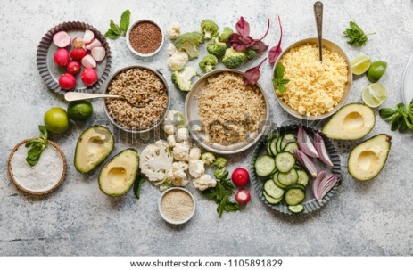
3. What do nutrients do for our body?  a) help our body be full  b) help our body function properly  c) help our body be fit | 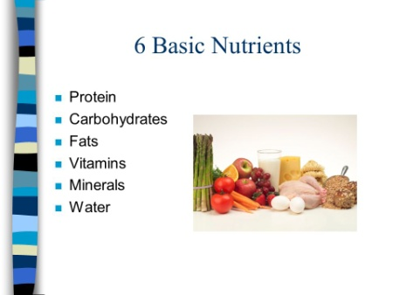
4. What types of fat do you now know?  a) healthy and unhealthy  b) organic and artificial  c) processed and unprocessed | 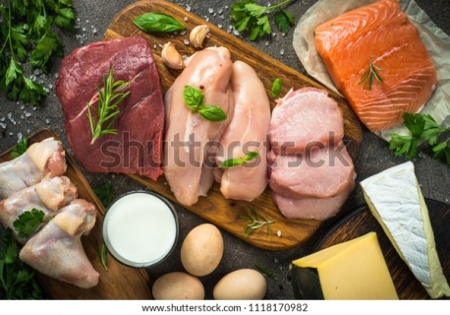
5. What are the sources of fiber?  a) meat and fish  b) milk and cheese  c) bread and seeds | 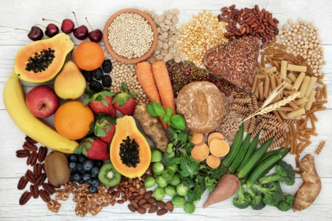
6. What does water do for the body?  a) helps digest  b) nourishes  c) supplies with minerals | 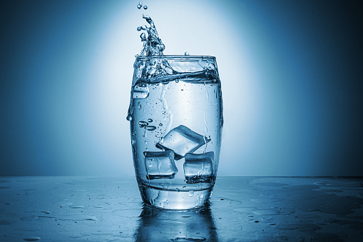

c) Scan the pictures and state what nutrients these foods are rich with.
A. 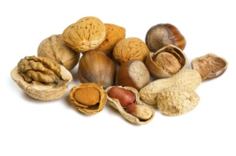 | C.  | E.  
B.  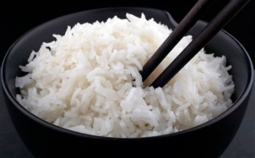 | D.  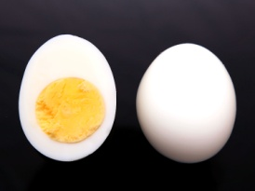 | F.  

3.20. a) What interesting topical information have you learned in this Module?

b) Scan the information below, surf the Internet for additional information and make a PowerPoint Presentation on your own “Healthy Diet”.
The energy provided by a well-digested food can be estimated if the gram amounts of energy-yielding substances (non-fibre carbohydrate, fat, protein, and alcohol) in that food are known. For example, a slice of white bread containing 12 grams of carbohydrate, 2 grams of protein, and 1 gram of fat supplies 67 kilocalories (280 kilojoules) of energy. Food composition tables (see table) and food labels provide useful data for evaluating energy and nutrient intake of an individual diet. Most foods provide a mixture of energy-supplying nutrients, along with vitamins, minerals, water, and other substances. Two notable exceptions are table sugar and vegetable oil, which are virtually pure carbohydrate (sucrose) and fat, respectively.

The Energy Value and Nutrient Content of Some Common Foods
Food | Energy (kcal) | Carbohydrate (g) | Protein (g) | Fat  (g) | Water (g)
White bread (1 slice,28g) | 67 | 12,4 | 2,0 | 0,9 | 9,2
White rice (1 cup, 186g) | 242 | 53,4 | 4,4 | 0,4 | 127,5
Low fat milk  (2,5%, 244g) | 121 | 11,7 | 8,1 | 4,7 | 17,7
Butter (1 tsp, 5g) | 36 | 0 | 0 | 4,1 | 0,8
Cheddar cheese (28g) | 114 | 0,4 | 7,1 | 9,4 | 10,4
Broiled beef (100g) | 272 | 0 | 24,7 | 18,5 | 55,7
Boiled potato (135g) | 117 | 27,2 | 2,5 | 0,1 | 103,9
Cabbage, raw (35g) | 9 | 2,1 | 0,5 | 0,1 | 32,0
Apple (138g) | 81 | 21,0 | 0,3 | 0,5 | 115,8

