Unit I. Human nutrition
Warm up
1. Answer the questions:
1. What is nutrition?
2. What disciplines are involved in the study of human nutrition?
3. What is the goal of nutritional science?

2. Practice the pronunciation of the following words:
Nutrition [njuːˈtrɪʃ(ə)n], substance [ˈsʌbstəns], interdisciplinary [ˌɪntə(r)ˈdɪsɪplɪnəri], preference [ˈpref(ə)rəns], disease [dɪˈziːz], release [rɪˈliːs], muscle [ˈmʌs(ə)l], essential [ɪˈsenʃ(ə)l], digest [daɪˈdʒest], occur [əˈkɜː(r)].

3. Read and guess the meaning of the following words:
Physiology [fɪziˈɒlədʒi], biochemistry [ˌbaɪəʊˈkemɪstri], biology [baɪˈɒlədʒi], molecular [məˈlekjʊlə(r)], cultural [ˈkʌltʃ(ə)rəl], tradition [trəˈdɪʃ(ə)n], secretory [sɪ'kri:t(ə)rɪ], energy [ˈenə(r)dʒi], optimal [ˈɒptɪm(ə)l], isolated [ˈaɪsəˌleɪtɪd].

Words and word combinations to be memorized:
Body tissues | ткани тела
full range of | полный спектр
to make up | составлять
the influence of (smth) on (smth) | влияние (чего-л.) на (что-л.)
chronic diseases | хронические заболевания
to supply | снабжать
metabolic activities | метаболические процессы
ultimate goal | конечная цель
chemical reactions | химические реакции
the bulk of the diet | основная часть рациона

 Read the text, translate it into Russian.
Text A. Human nutrition
Human nutrition is a process by which substances in food are transformed into body tissues and provide energy for the full range of physical and mental activities that make up human life. | 
The study of human nutrition is interdisciplinary in character, involving not only physiology, biochemistry, and molecular biology but also fields such as psychology and anthropology, which explore the influence of attitudes, beliefs, preferences, and cultural traditions on food choices.
The ultimate goal of nutritional science is to promote optimal health and reduce the risk of chronic diseases.

The human body can be thought of as an engine that releases the energy present in the foods that it digests. This energy is utilized partly for the mechanical work performed by the muscles and in the secretory processes and partly for the work necessary to maintain the body’s structure and functions.
A nutrient is considered “essential” if it must be taken in from outside the body—in most cases, from food. Foods supply nutrients essential to the manufacture of the new material and provide energy needed for the chemical reactions involved. Nutrients work in collaboration with each other in the body, not as isolated entities. | 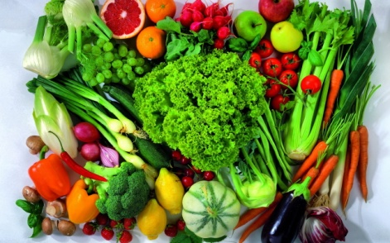
Source: https://www.britannica.com/science/human-nutrition
The six classes of nutrients necessary for humans, which are found in foods, are carbohydrates, lipids (mostly fats and oils), proteins, vitamins, minerals, and water. Carbohydrates, lipids, and proteins constitute the bulk of the diet, amounting together to about 500 grams (just over one pound) per day in actual weight. These macronutrients provide raw materials for tissue building and maintenance as well as fuel to run the myriad of physiological and metabolic activities that sustain life. In contrast are the micronutrients, which are not themselves energy sources but facilitate metabolic processes throughout the body: vitamins, of which humans need about 300 milligrams per day in the diet, and minerals, of which about 20 grams per day are needed. The last nutrient category is water, which provides the medium in which all the body’s metabolic processes occur.
 1.1. Answer the questions to the text.
1. What do the nutrient substances do for the human organism?
2. What influences the food choices?
3. What can human body be thought of?
4. Where is human energy utilized?
5. What nutrient can be considered ‘essential’?

1.2. Agree or disagree with the following statements. If you disagree, give your reasons.

1. Macronutrients provide raw materials to run the metabolic activities that sustain life.
2. There are three essential classes of nutrients necessary for humans.
3. Nutritional science is the science about food.
4. Foods provide energy for the full range of physical activities that make up human life.
5. Water provides the medium in which all the body’s metabolic processes occur.

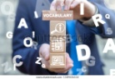 1.3. Match up the terms on the left with the definitions on the right.
1.substance | a) v. let someone kept in place leave
2.energy | b) adj. completely necessary
3.nutritional | c) n. separate unit with its own character
4.release | d) n. type of liquid, solid, or gas
5.utilize | e) n. substance that something grows or exists in
6.maintain | f) v. keep something the same
7.essential | g) n. measurement
8.involve | h) n. extremely large number of
9.entity | i) v. include something as necessary part
10.weight | j) n. supply of physical power that you have
11.raw | k) v. to make something possible
12.facilitate | l) v. provide conditions for something to happen
13.sustain | m) adj. concerning food for keeping you healthy
14.medium | n) adj. not cooked, or not thoroughly cooked
15.myriad | o) v. use something

1.4. Replace the words in italics by their synonyms from Text A.
1. Vegetarian diet is disputable.
2. All nutrients are important for children’s growth.
3. Foods supply materials for metabolic procedures in the organism.

1.5. Match up the words in the right and the left columns to make expressions. Make up your own sentences using these expressions for your partner to translate.
1. to make up | a. metabolic processes
2. to facilitate | b. energy
3. to promote | c. the risk
4. to release | d. nutrients
5. to reduce | e. human life
6. to supply | f. the body’s structure
7. to maintain | g. optimal health

1.6. Give English equivalents to the following.
Обеспечивать энергией; междисциплинарный характер; включая в себя; не только; энергия частично расходуется; структура и функции организма; необходимо для химических реакций; основная часть; происходят метаболические процессы.
 1.7. Match the Russian word with the English equivalent.
взаимодействие | - collaborate, collaborative, collaboration;
преобразованный | - transformed, transform, transformation;
оптимальный | - optimize, optimization, optimal;
осуществляемый | - performed, perform, performance.

1.8. Scan the text and complete the gaps with the words that are derived from the words on the right.
Our epidemics of dietary disease have prompted a great deal of research into what humans are meant to eat for _________(optimize) health. In 1985, an influential article ________ _______(highlight) in my video The Problem With the Paleo Diet Argument was published proposing that our chronic diseases stem from a disconnect between what our bodies ate while _______________ (evolve) during the Stone Age (about 2 million years ago) and what we’re stuffing our face with today. The proposal advocated for a return towards a hunter-gatherer type diet of lean meat, fruits, vegetables, and nuts.
It’s reasonable to assume our ______________(nutrition) requirements were established in the prehistoric past. However, the question of which prehistoric past we should emulate remains.
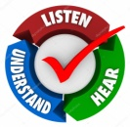1.9. a) Watch the video ‘Nutrition for a Healthy Life’
https://www.youtube.com/watch?v=c06dTj0v0sM

b) Do the quiz.

1. What causes us to age?  a) eating habits and environment  b) smoking and drinking alcohol  c) lack of sleep | 
2. When can our cells, tissues and organs perform normally?  a) when we keep fit  b) when they are not damaged  c) when we regularly consult a doctor | 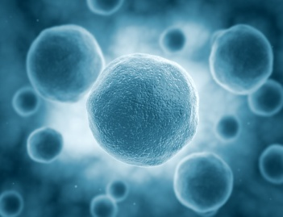
3. When do we start experiencing aging?  a) early in life  b) when we are 35  c) when we feel ill | 
4. How to reduce the risk factors of early aging?  a) reducing smoking and drinking coffee  b) reading a lot of articles about aging  c) keeping healthy lifestyle and diet choices | 

c) List the basic ideas of Healthy Nutrition for the human organism.

1.10. Sum up the main ideas of Text A.
1.11. Look at the following words and try to predict what Text B will be about.
Health, improvement, lifestyle, diet, signal, hunger, indication, food, chemicals, minerals, vitamins, life-savers, pleasures, well-being.

1.12. a) Read Text B and find the appropriate heading for each passage.
a. Science about food.
b. Diet for health.
c. Responsibility for health.
d. Body signals.
e. You are what you eat.
f. Diet and your lifestyle.
g. Food to live.

Text B. 1. More and more people today are choosing to take greater responsibility for their own health. We now recognize that we can influence our health by making an improvement in lifestyle – a better diet, more exercise and reduced stress.
2. Your health and general well-being is very much determined by what you eat and even a minor change in your diet can help to strengthen your resistance to many illnesses.
3. It seems almost absurd to state that you need food to live. The body has a built-in alarm signal – hunger – to tell you when your supply of food, the ‘fuel for the body’, is low. That’s why you are never in serious danger of forgetting to eat. This alarm signal is also choosy and at times asks for specific supplies, for example, sweet things when your body sugar is low or water when you are thirsty.
4. What many people fail to recognize is that their bodies have more than just one signal. Tiredness, aches and pains, stress, even chronic disease – all these can be indications of a diet that is lacking nutrition. But we can see the results of a bad diet immediately (often the effects take years to develop), few people realize just how closely bodily health is linked to what they eat.
5. You are what you eat, and the food you eat effects the way you feel and the way you look all through your life.
6. Scientists now know that food and its affects are as complex as our own bodies. Of thousands of chemicals, minerals and vitamins found in a single food, many are potential life-savers or hazards to health, depending on how much is consumed over time. The link between food and health is an everyday complex issue. So, you should learn how to balance your food intake. Small but well-informed changes to your diet will make a great difference to your well-being.
7. By matching your diet to your lifestyle and developing better eating habits both at home and when you eat out, you can keep yourself in the best health. And also, you have to understand the proper balancing of the social pleasures and of the body. The foods you eat possess powerful capabilities to help and harm.
Source:
b) Do you think the heading “Eating for Good Health” will come for this text?
c) What other pieces of advice can you give to stay healthy? Give your reasons.
1.13. Find words in Text B which mean the following.
a. position of being in charge of something
b. know who or what someone or something is
c. affect a situation or someone’s behaviour
d. process of becoming, or making something, better
e. make something less in size, amount etc
f. satisfactory state of being happy, healthy etc
g. control what something will be
h. make body strong
i. substance to produce power
j. lack of energy
k. situation of not having enough of something
l. things, or events: be related
m. change or influence something
n. something that could be dangerous
o. subject people discuss or argue about
p. amount of something you eat or drink
q. have a quality or ability
r. injure, damage, or hurt someone or something

1.14. Translate from Russian into English.
Испытывать недостаток питательных веществ; тесно связанный; плохое питание; влиять на здоровье; приспосабливать режим питания к образу жизни; состояние организма; регулировать прием пищи.

1.15. Find 8 words from Text B in the puzzle.
g | e | n | h | o | p | e | r | n | y | i | p | e | v | e | t | s | o | m | s
g | r | u | e | s | t | l | a | c | k | n | e | n | s | w | i | b | a | b | o
k | o | t | a | p | e | s | r | y | z | h | i | u | y | k | o | a | n | u | r
l | a | p | l | o | c | h | k | a | v | o | l | t | o | s | y | l | t | l | e
n | n | y | t | d | u | h | z | h | i | z | n | r | w | y | m | a | m | u | s
g | r | a | h | f | i | k | a | l | a | m | p | i | a | d | a | n | e | r | v
o | p | p | p | s | q | d | i | e | t | l | e | e | r | y | b | c | c | e | t
d | i | s | e | a | s | e | g | o | j | u | r | n | a | v | l | e | k | l | u
d | o | m | i | a | i | n | g | r | e | s | t | t | i | p | o | v | o | l | m
h | a | r | m | a | t | u | r | u | v | r | e | z | h | f | u | e | l | t | y

1.16. Match up the words in the right column with their opposites in the left column.
1.health | a. benefit
2.influence | b. chaos
3.balance | c. general
4.low | d. cause
5.harm | e. high
6.specific | f. disease
7.complex | g. simple

1.17. Scan the text and change sentences in the active voice into passive and vice versa where possible.

Ingredients such as salt, sugar and fat are sometimes added to processed foods to make their flavour more appealing and to extend their shelf life, or in some cases to contribute to the food's structure, such as salt in bread or sugar in cakes.  Buying processed foods can lead to people eating more than the recommended amounts of sugar, salt and fat as they may not be aware of how much has been added to the food they are buying and eating. | 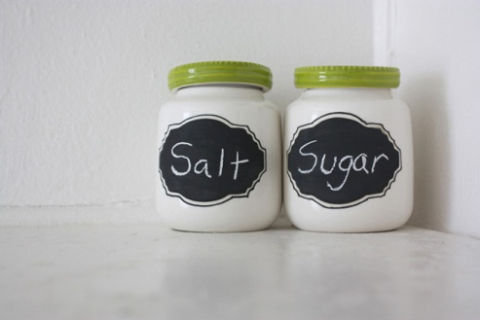
 | 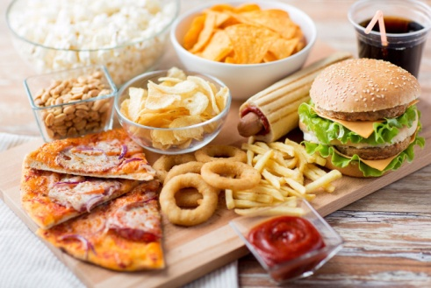

1.18. Fill in the blanks with the suitable verb from Ex. 1.13 in the correct form.
1. Every centre was encouraged __________ its social science research. (more powerful)
2. You _______specific evidence. (absence)
3. Bonds __________a mother and son. (connect)
4. Your observations ___________your food preferences in the nearest future. (effect).

1. 19. Write a report about Healthy lifestyle.

 1.20. Basing on your report (Ex. 1. 19), interview your classmate(s) about their healthy lifestyle.
Food | 
 | Lifestyle

