Unit 7 The Latest Technologies in Metalworking

Starting Up

In your opinion, how can modern manufacturing technologies such as Artificial Intelligence (AI), 3-D printing, automation and robotics, be applied to processing of metals?

Study the Vocabulary:
 | Word | Translation
 | advancement /ədˈvɑːnsmənt/ | успех, прогресс
 | to affect /əˈfekt/ | оказывать влияние
 | obstacle /ˈɒbstəkəl/ | препятствие
 | challenge /ˈtʃæləndʒ/ | трудность, стимул, сложная и интересная задача
 | facilities | технические средства
 | to outweigh /aʊtˈweɪ/ | превосходить
 | to be on the verge /vɜːdʒ / | находиться в шаге
 | to keep up with requirements | соответствовать требованиям
 | twin-turret technology | станки с двумя револьверными головками
 | turn-mill technology | токарно-фрезеровальное оборудование
 | to emerge /ɪˈmɜːdʒ/ | появляться
 | diversification /daɪˌvɜːsɪfɪˈkeɪʃən/ | разнообразие
 | lean manufacturing /liːn/ | экономичное производство, производство без потерь
 | longstanding | давний, многолетний
 | to boost production /buːst/ | повысить производительность
 | capacity /kəˈpæsəti/ | способность
 | shear /ʃɪə/ | дисковые ножницы
 | planer /ˈpleɪnə/ | строгальный станок
 | to catch up | догонять
 | to enhance /ɪnˈhɑːns/ | усиливать
 | scalability /ˌskeɪləˈbɪləti/ | масштабируемость
 | to reduce overheads | сокращать накладные расходы
 | at a crossroads | на распутье
 | to embrace a technology /ɪmˈbreɪs/ | научиться пользоваться технологией

Exercise 7.1. While reading, fill in the table, where applicable:
 | Modern technology; main features | Advantages | Threats

How Technology is Changing Metalworking Businesses
Technology has evolved at a rapid rate in the recent years, changing the world as we know it in many different sectors. The metalworking industry is not different, where some advancements continue to play a role and affect businesses throughout the world.
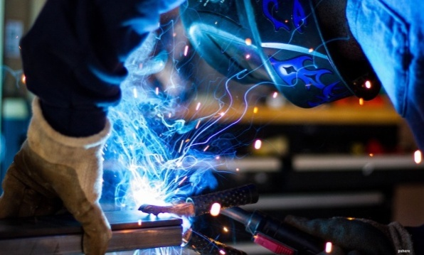
The growth of modern technology presents a range of new opportunities, but also establishes new obstacles and challenges. So, how is technology changing the metalworking industry for the better and worse? Let’s take a closer look.

3-D Printing
The excitement around the world of 3-D printing has largely been limited to the plastics industry in recent years as metal printing has been difficult due to a lack of reliable facilities. However, Desktop Metal* is now on the verge of changing the metalworking industry forever. In truth, the negative impacts probably outweigh the positives.
Opportunities offered by the 3-D printing are set to challenge and potentially kill at least some parts of the traditional metalworking sector. 3-D printing will allow companies to print prototypes, small production runs, and a variety of parts without needing the experts. Moreover, metal 3-D printing may lead to some problems such as porosity, density, stress, cracking, etc. What are the biggest disadvantages of using the 30D technologies in traditional manufacturing?

High-Speed Machining (HSM)
Nowadays, metalworking businesses assume that technological changes present challenges, not only financial. However, modern facilities enable companies to keep up with the ever-changing requirements of their consumers. HSM is one idea that continues to reach more and more companies.

Twin-turret and turn-mill technologies are also emerging as a popular solution for metalworking companies. This has allowed for the diversification of production lines, lean manufacturing processes, production monitoring, and a variety of additional advancements. Laser cutting and plasma cutting are longstanding techniques that boost production speed and accuracy, too.

Artificial Intelligence
Artificial intelligence has been adopted in many fields, and the metalworking sector is now catching up to complete certain tasks using automation. Automation doesn’t mean that there would no longer be a need for human intervention — rather it introduces the idea of humans working with/on smarter machines as a way of reducing errors. Mistakes on metal materials can be costly for both the manufacturer and the end-customer.
Machine learning as a part of AI seems to be something out of science fiction. But translated into metal fabrication, it isn’t really as complicated as it seems. Simply put, machine learning is one application of AI that suggests that machines have the capacity to “learn” from previous experiences without any need for reprogramming. This means that the machine is able to explore and analyze patterns.

AI also provides opportunities for more efficient metal cutting techniques. This is because already-existing machines like lathes, drills, shears, or planers can be integrated with computer systems.
The use of AI can open the door to 24/7 manufacturing. It can also enhance production outcomes. This presents an opportunity for faster scalability. Perhaps most importantly, especially given the competition from outside industries, the use of modern facilities can significantly reduce the overheads without completely removing the need for skilled experts in the field.
It’s an important time for the metalworking industry as many businesses find themselves at a crossroads. Those that aren’t willing to change may find themselves left behind. However, those who will embrace the latest technologies will be able to provide fast production, incredible accuracy, and excellent customer service.
*Desktop Metal is a public American technology company that designs and markets 3D metal printing systems.
After-reading exercises:
Exercise 7.2 Answer the questions to the text:
- How can modern technologies affect the metalworking industry?
- Is the technology of 3-D printing more applicable to metals or plastics? Why?
- What are the potential threats of using the 3-D technology in traditional manufacturing?
- What are the new HSM technologies and techniques? What do they allow companies to achieve in production?
- How can automation change metalworking? What is the main argument for introducing automation in product manufacturing?
- How can machine learning be applied to metalworking?
- How can AI work for metal cutting?
- What conclusion does the author of the article arrive at, about the role of using modern technologies in metal processing?

