The Rules of Netiquette
PRE-TASK 1 Proofreading
Proofread your blog name, motto and posts. Correct spelling, grammar or syntax mistakes, if any.
Always go over your post several times to ensure that you've removed every mistake.

PRE-TASK 2 Using Images and Texts Legally Online
1.Check up whether you have copied any text that someone has written and pasted it into your blog without acknowledging the source. If yes, write down after the text Retrieved from https:// ….
2. Check up whether you have copied any pictures and pasted them into your blog without acknowledging the author and source. If yes, read How and Why to Cite Stock Photos in Your Medium Stories at https://writingcooperative.com/how-and-why-to-cite-stock-photos-in-your-medium-stories-3c6c554f48b0 and make correct citation telling where a photo came from, and give a link back to the original photo.

TASK
Search and study 10 internet etiquette core rules.

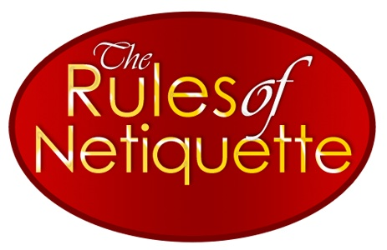
Netiquette is derived from the words network and etiquette. Etiquette is a social code. Contemporary standards comprise the code. Therefore, Internet etiquette, Netiquette, is the social code of the Internet. The rules are conventions for online communication that make everyone comfortable. Most people follow them, which determines what is normal. Combining these words into a term enables it to become a philosophy.

1. Search and study 10 internet etiquette core rules.
If you need more explanation or you are interested in extra information about some rules, read about them from Virginia Shea, the author of the book Netiquette at http://www.albion.com/netiquette/corerules.html
2. Search the internet for some examples of Netiquette for Bloggers.
3. Make your own list of Basic Netiquette Rules for Bloggers that you find most important.

4. Add to your list some of the rules from https://heimdalsecurity.com/blog/netiquette-rules-safety/
5. Publish your list of Basic Netiquette Rules for your Blog.
6. Try to follow you own rules. You are expected to report about it in your final task at the end of the semester.
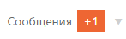Report about the task you have done to the Teacher via DiSpace.

